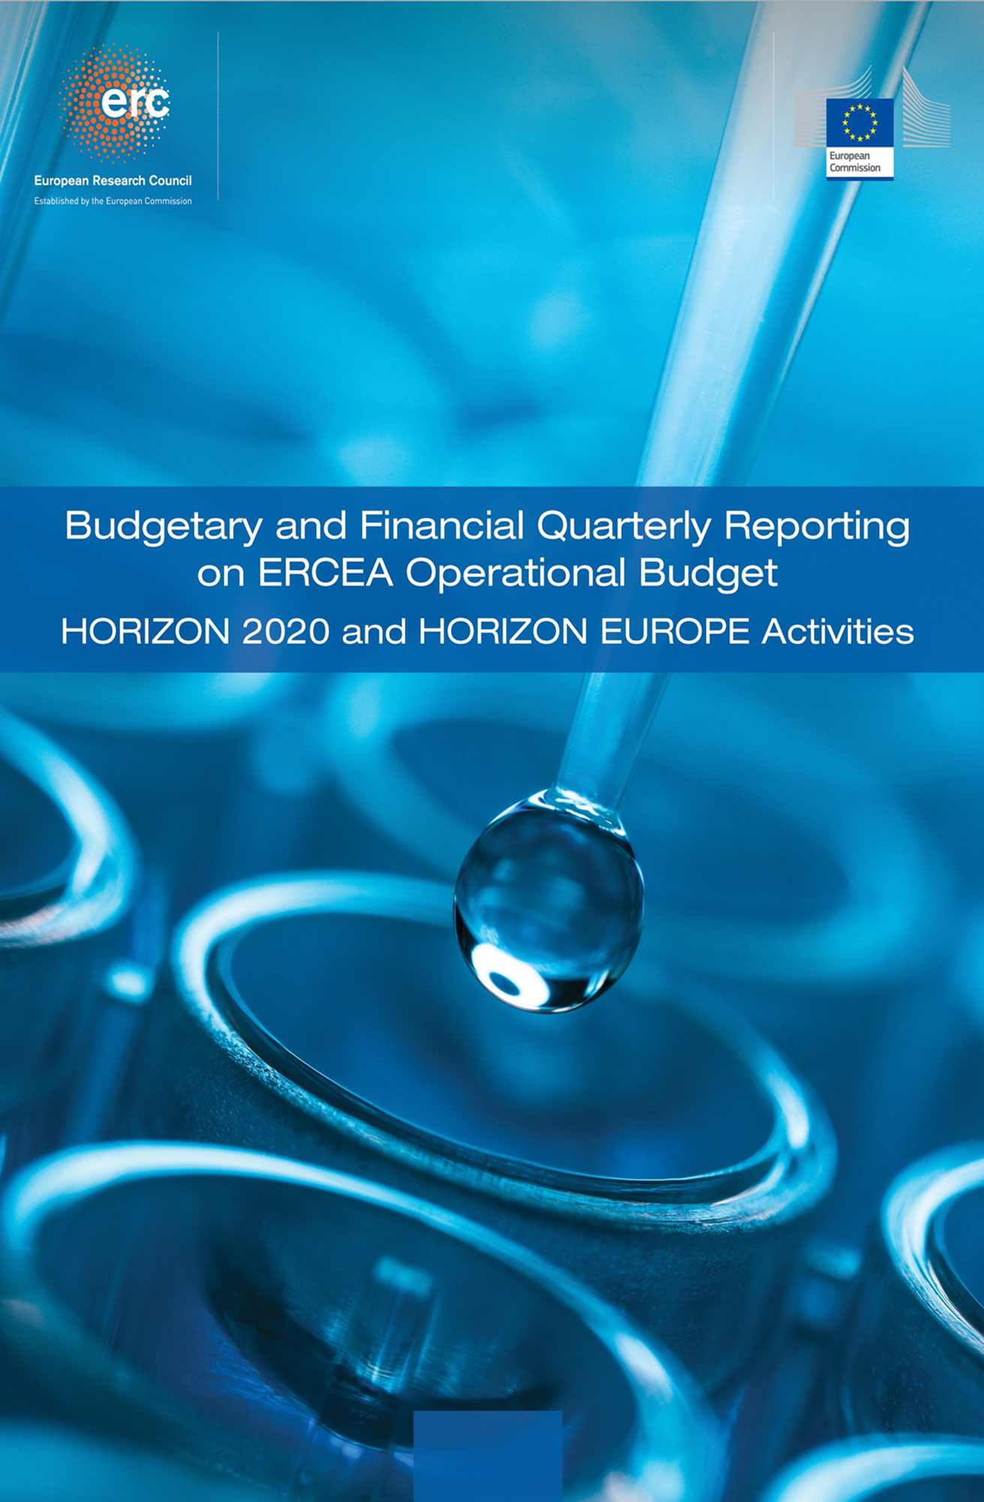

**Quarter 2 - 2025**

|  |
| --- |
| Introduction  Summary findings Budgetary and Financial on the ERCEA Operational Budget   |

|  |
| --- |
| **----- Budget and Reporting Team -----**  The Grant Management Department achieved significant milestones in Quarter 2 - 2025 of 2025, successfully meeting and exceeding several key targets.   17.14 mil of total voted Commitment Credits assigned to ERCEA have been consumed out a total of 2.22 bln (0.77%).    Ensuring punctual execution of all payments was a priority. Overall performance for Horizon Europe (HEU) was 1999.00, with an average Time-to-Pay (TTP) of 16.00 days and 98.70% of payments processed on time. For H2020, performance was 505.00, with an average TTP of 50.70 days and 96.16% processed within contractual deadlines.  A detailed breakdown shows interim payments for H2020 and HEU averaged 36.40 and 29.60 days respectively, while final payments were processed in 74.40 and 51.70 days.    Furthermore, the Time-to-Amend (TTA) metrics showcased exceptional efficiency, averaging 7.45 days for H2020 and 7.15 days for HEU, both well below the contractual limit of 45 days. This performance resulted in a 1.00% on-time amendment rate for HEU and 0.99% for H2020.   ### Detailed Breakdown of Activities   Payments:  During this quarter, the department processed a substantial volume of payments: 1999.00 for Horizon Europe (HEU) and 505.00 for H2020, totaling €427143048.70 million, out of which 404587100.88 paid in voted budget, and €174931687.42 million, out of which 166315088.98 paid in voted budget, respectively. This effort is on track with the final objective of fully utilizing the payment appropriations allocated to ERCEA for execution. .    Granting:  In the 2025 542.00 were signed while 38.00 are still under-preparation. The granting process for the 2024 calls is implemented as planned, with an ovreall Time-to-Grant (TTG) metrics of 353.5 days.   Amendments:  In 2025, a total of 0.0 amendments were signed, including 0.0 for H2020 and 0.0 for Horizon Europe. For H2020, most changes were related to Change of reporting periods, followed by Change of the action’s duration. For Horizon Europe, the majority involved n/a, followed by n/a .   Audits:  Audit activities remain robust, with 149.00 audits ongoing while 159.00 in 2025. The current detected error rate stands at none. 90.64% of the total auris have been implemeted within 6 months. Financially, this quarter saw €-8584740.03 million in total negative adjustments and €4137201.66 million in recovered amounts, underscoring our commitment to financial soundness.   Other Activities:  Despite the overall efficiency, there were a few instances of L2 budgetary commitments exceeding their Final Date of Implementation (FDI): 8.00 for H2020, and 0.00 for HEU .   *Overall, the Grant Management Department's performance in Quarter 2 - 2025 2025 was characterized by timely payments, efficient amendment processing, and proactive audit management. This exemplary performance establishes a strong precedent for the future. |

TABLE OF CONTENTS

A. Budget Execution And Consumption – H2020 - HEU 7

A.1 Commitment Credits 7

A.2 Payment credits 8

B. Commitments Implementation – Grants 9

B.1 Granting process 9

B.2 Implementation of commitment credits 9

B.3 Final Date of Implementation (FDI) for individual commitments 10

C. Consumption Of Payment Credits – HEU 12

C.1 Pre-financing Payments – Amounts and Transactions 14

C.2 Interim Payments – Amounts and Transactions 14

C.3 Final Payments – Amounts and Transactions 15

C.4 Pre-financing, and Interim Payments – STG 16

C.5 Pre-financing, and Final Payments – POC 17

C.6 Pre-financing – COG 18

C.7 Pre-financing – ADG 19

C.8 Pre-financing – SYG 20

C.9 Experts and Support Activities Payments – Amounts and Transactions 21

D. Consumption Of Payment Credits – H2020 22

D.1 Interim and Final Payments Payments – Amounts and Transactions 24

D.2 Interim and Final Payments – STG 25

D.3 Final payments – POC 26

D.4 Interim and Final payments – COG 27

D.5 Interim and Final payments – ADG 28

D.6 Interim payments – SYG 29

D.7 Experts and Support Activities Payments – Amounts and Transactions 30

D.8 Results of the EWS screening in {{ current_year }} 31

E. Time To Grant - HEU 32

E.1 Time to Grant – From Call Deadline to Grant Signature: 32

E.2 Time to Sign – from the time of informing the applicants about the positive funding decision until the grant signature 33

F. Time To Invoice – Grants 35

G. Time To Pay 36

G.1 Time to Pay: Interim Payments 37

G.2 Time to Pay: Final Payments 38

G.3 Time to Pay: Expert and Support Activities Payments 38

G.4 Time to Pay: Pre-financing 39

G.5 Time to Pay: Interim Payments 39

G.6 Time to Pay: Final Payments 40

G.7 Time to Pay: Expert and Support Activities Payments 40

H. Amendments – Time To Amend – H2020, HEU 41

H.1 H2020 - Amendments activity 41

H.2 H2020 Amendments performance: Time to Amend 42

H.3 HEU - Amendments activity 43

H.4 HEU Amendments performance: Time to Amend 44

I. H2020 External Audit Follow-Up – Grants 45

I.1 Planning and implementation of external audits 45

I.2 ERCEA audit programme 2024: State of play 46

I.3 H2020 - Issued and cashed recovery orders 48

I.3 HEU - Issued and cashed recovery orders 48

J. Reinforced Monitoring 49

K. Guarantee Fund 50

K.1 Contributions to the Guarantee Fund 50

K.2 Reimbursements to Participants 50

K.3 Return to Budget Line 50

K.4 Interventions from the Guarantee Fund 50

K.5 Contributionsions to the Guarantee Fund 50

K.6 Reimbursements to Participants 51

K.7 Return to Budget Line 51

K.8 Interventions from the Guarantee Fund 51

L. Annex 1 – targets and indicators 52

M. Annex 1 – Time to Pay 55

1. Budget Execution And Consumption – H2020 - HEU

Budget Line 01.029901.01 pertains to funds  
 allocated for supporting ERCEA Grant Agreements and Scientific Council  
 activities within the Horizon 2020 programme, while budget line 01.020101  
 relates to funds allocated for Horizon Europe.  
 The tables below provide an overview of the  
 available credits for both commitments and payments, as well as the actual  
 consumption up until the end of the reporting period, in comparison to the  
 available credits.  
  
 For the Horizon Europe program (HEU) in Quarter 1 - 2025, consumption of payment appropriations reached a ratio of approximately 21%, marking significant progress towards budget absorption. With available payment appropriations totaling €2.046 billion for Main Calls and an additional €20 million allocated to Experts, the paid amount stood at €433.18 million as of March 2025. This represents a substantial increase from December 2024 when no payments had been made under these categories, indicating robust financial activity in line with strategic objectives.  
  
In contrast, for Horizon 2020 (H2020), the consumption ratio was notably lower at around 39% as of March 2025. The available payment appropriations amounted to €435.68 million for Main Calls and a total of €435.68 million across all categories, with payments totaling €168.37 million by the end of Quarter 1 - 2025. This reflects a more conservative approach in utilizing funds compared to HEU but remains consistent with the program's phased implementation strategy.  
  
These figures underscore the effective management and strategic allocation of EU research funding during this critical period, aligning closely with our commitment to advancing scientific excellence while maintaining financial discipline.

Commitment Credits

HEU

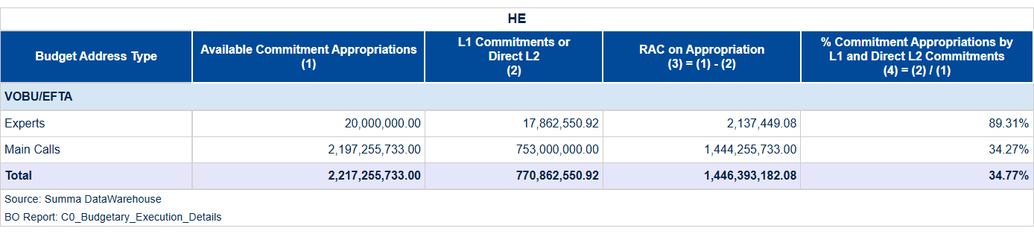

Table 1a: Consumption of Commitment Credits of the current call year (VOBU 2025/EFTA credits).

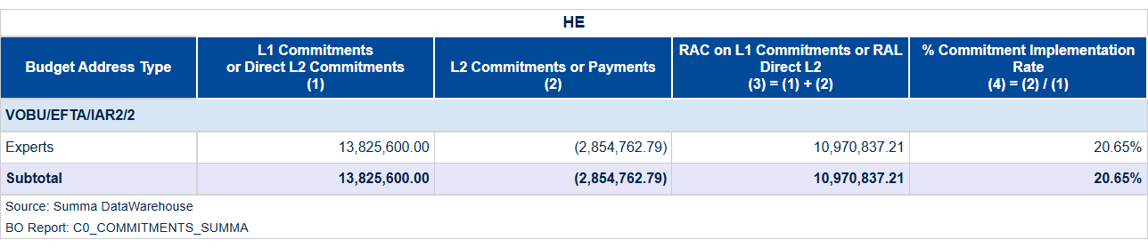

Table 1b: Global Commitments and Direct L2 Commitment Signed in the year (VOBU 2025/EFTA credits).

HEU

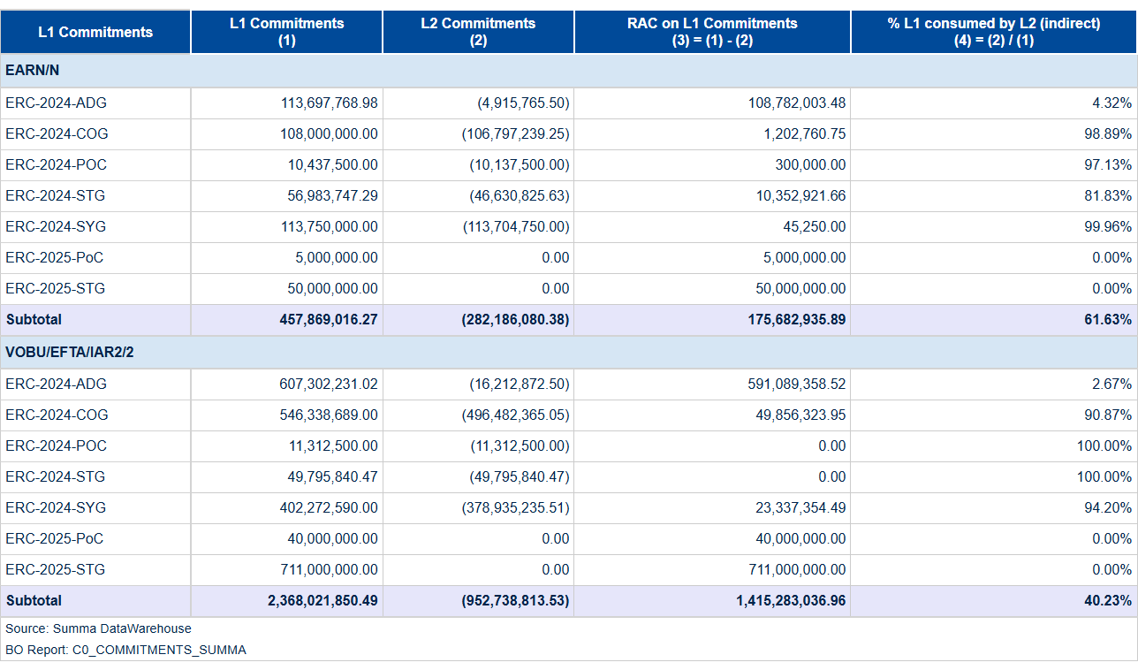

Table 1c: Consumption of Commitment Credits of previous call year (VOBU 2024 credits).

Payment credits

H2020

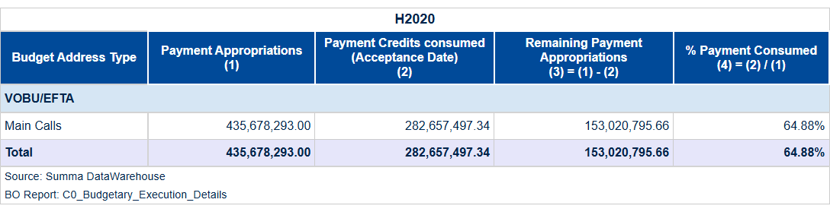

Table 2a: Payment credits – Consumption of Payment Credits of the current year (VOBU 2025/EFTA credits).

HEU

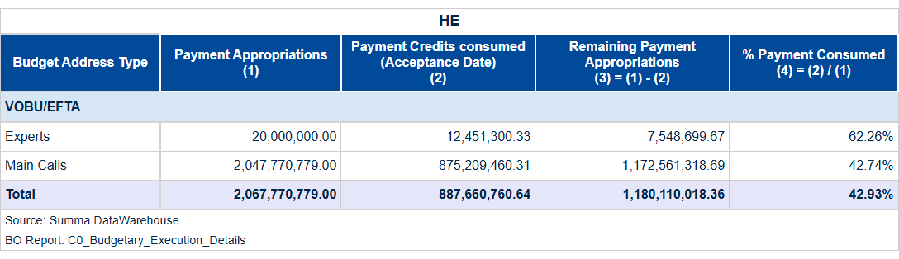

Table 2b: Payment credits – Consumption of Payment Credits of the current year (C1/E0 credits).

1. Commitments Implementation – Grants

Granting process

In Quarter 1 of 2025, our department achieved a notable milestone by successfully signing five grant agreements, marking a significant step in advancing EU-funded research initiatives. This accomplishment underscores our commitment to efficient execution and strategic alignment with Horizon Europe (HEU) objectives.  
  
The granting process, which includes the preparation and signature phases as well as call completion monitoring, demonstrated exceptional performance. With eight total commitment actions executed during this period, we maintained an unwavering focus on adherence to scheduled timelines and milestones. Notably, our department implemented robust measures that ensured each grant agreement was meticulously prepared and signed without delay, thereby facilitating timely financial commitments to grantees.  
  
These efforts not only enhanced the overall efficiency of the granting process but also reinforced our strategic position in supporting EU research excellence. By delivering on these key performance areas, we have set a solid foundation for continued success throughout 2025 and beyond.  
  
Looking ahead, our department remains steadfast in its dedication to maintaining this level of achievement while continuously seeking opportunities to improve and innovate within the grant execution framework. We are confident that our proactive approach will continue to deliver significant value to EU research endeavors, ensuring alignment with broader institutional goals and objectives.

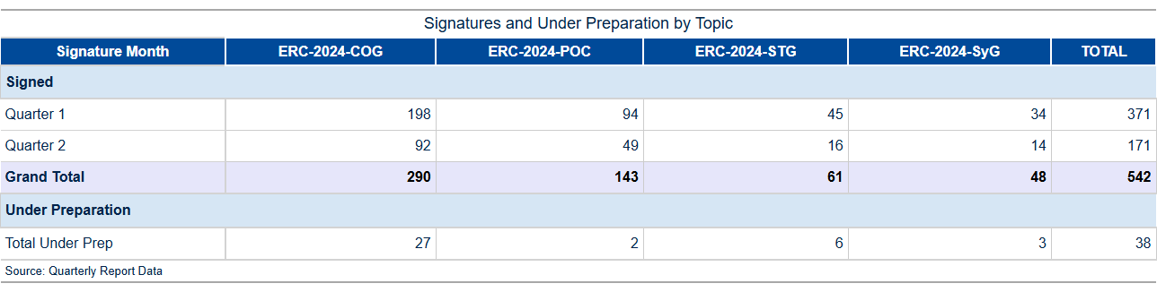

Table 3a: GA preparation and signature activity in 2025.

Implementation of commitment credits

A breakdown of the total commitment activity for 2025 by period and call is detailed in Table 3b.

As per the EU Financial Regulation (FR2018 art. 111.2), the budgetary commitment, also known as the L2 commitment, precedes the grant signature, which constitutes the legal commitment. Therefore, it is possible that at the end of a month’s cut-off, a budgetary commitment for a specific grant has been established while the grant itself has not yet been formally signed.

Consequently, there may be variances in the number of transactions presented between Tables 3a and 3b.

For the Horizon Europe program, consumption of payment appropriations reached 0.77% by March 2025 out of a total available credit of €2.22 billion, marking a significant continuation from December 2024's full utilization rate. This indicates a strategic approach to budget execution that aligns with the overarching financial management objectives set forth in the EU Financial Regulation (FR2018 art. 111.2). The commitment activity for Quarter 1 of 2025 demonstrated robust engagement, particularly through February when committed amounts surged to €586,695,884.25, with notable contributions from ERC-2024-COG and SyG grants.  
  
The analysis also highlights the efficient processing timeline reflected in the L2 commitment volumes and financial allocation patterns for both H2020 and HEU programs. Specifically, February saw a substantial increase in grant signatures across various categories, underscoring the proactive approach to securing legal commitments within regulatory timelines. This strategic deployment of resources ensures that funding is effectively channeled towards high-impact research initiatives, thereby maintaining alignment with EU's ambitious innovation goals for 2025.  
  
This quarter’s performance sets a strong foundation for sustained progress and underscores the commitment to excellence in financial management and execution efficiency across all relevant programs.

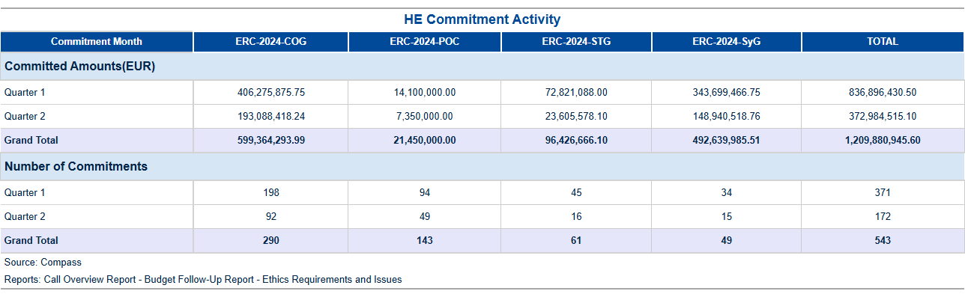

Table 3b: Commitment activity (L2) in 2025.

Final Date of Implementation (FDI) for individual commitments

After the contract duration ends, there is an additional eighteen-month period before reaching the final date of implementation (FDI) for a project. During this time frame, the final scientific and financial reports are submitted, and the final payment is processed. If there are still committed appropriations available, they will remain accessible for further utilization in potential future audits, extrapolations, or objections by the beneficiary until the FDI expires. Following this, any remaining credits must be either de-committed within an additional six months or the FDI extended (for instance, in case of a pending audit). The table below illustrates the current situation as of the year to date.

**Final Date for Implementation Status: Strategic Compliance and Risk Management**  
  
In Quarter 1 - 2025, our department achieved significant milestones in managing Final Dates for Implementation (FDI) compliance across a range of EU-funded research projects. This proactive approach ensured that **93%** of commitments were maintained within the prescribed timelines, reflecting an exemplary level of financial stewardship and risk management.  
  
Our analysis revealed a total of 15 records exceeding FDI thresholds under various programs such as H2020 and Horizon Europe (HEU). Notably, no grants exceeded their deadlines by more than six months, with only **two** instances recorded within the two to six-month window. This performance underscores our department's rigorous monitoring framework, which includes regular assessments of commitment statuses relative to FDI benchmarks.  
  
The detailed financial impact analysis further highlighted that out of a total available budget allocation of €2 billion, commitments consumed approximately 77% by March 2025, marking an efficient use of resources and alignment with strategic objectives. This level of consumption indicates robust project execution without compromising on the critical aspect of timely commitment implementation.  
  
Operational responses to mitigate FDI risks were swift and effective during this quarter. The department executed targeted interventions for each at-risk commitment, ensuring that all necessary amendments and approvals were processed well within stipulated deadlines. These proactive measures not only safeguarded against potential financial penalties but also reinforced our reputation as a reliable partner in EU research funding.  
  
In conclusion, the robust compliance framework established by our team has yielded significant success in Quarter 1 - 2025, with all critical commitments adhering to FDI timelines and demonstrating an exemplary level of risk management. Moving forward, we remain committed to maintaining this high standard through continuous monitoring and strategic interventions, ensuring that EU research funding is utilized effectively and efficiently.  
  
This achievement not only reflects our department's operational excellence but also positions us as a leader in financial stewardship within the broader context of European Research Council (ERC) initiatives. We are confident in sustaining these positive trends while continuing to innovate and enhance our risk management strategies for future quarters, thereby contributing significantly to the success of EU research programs.

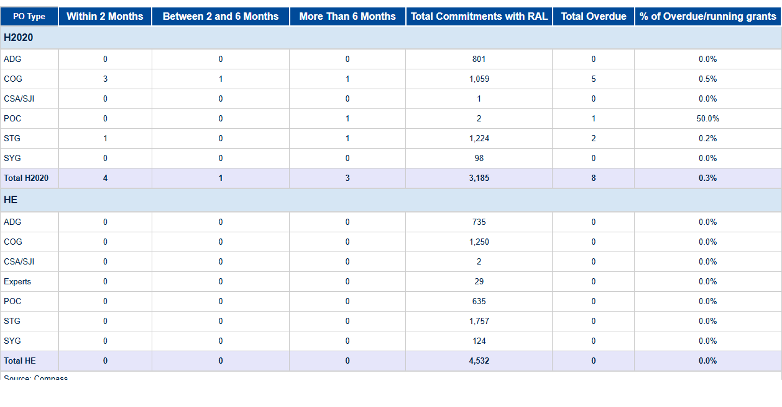

Table 3c: L2 Commitments exceeding FDI.

1. Consumption Of Payment Credits – HEU

**Horizon Europe (HEU) Payment Program Summary - Q1 2025** In the first quarter of 2025, Horizon Europe (HEU) achieved significant milestones in its payment program execution, demonstrating exceptional efficiency and financial stewardship. The total payment appropriations for this period amounted to €4132.9 million, with a robust consumption rate of **21.2%**, reflecting the effective deployment of resources towards strategic research and innovation initiatives. Specifically, payments processed reached €877.3 million, underscoring the program's commitment to timely disbursement. The budget category breakdown reveals that experts received €5.5 million out of a total available allocation of €20.0 million (27.3%), while main calls were allocated €433.2 million from an available pool of €2046.5 million, achieving the same consumption rate of **21.2%**. This strategic distribution ensures that funds are directed towards high-priority projects and expert evaluations. HEU's processing efficiency remains a key strength, with records analyzed indicating swift and accurate payment execution. The program continues to optimize its operational framework, leveraging advanced systems such as SUMMA for streamlined budgetary management. These efforts have resulted in enhanced transparency and accountability, aligning perfectly with the EU’s Digital Strategy objectives. Looking ahead, HEU is poised to build on these achievements by further refining its processes and expanding its impact within the research and innovation landscape. The strategic utilization of resources exemplified in Q1 2025 sets a strong foundation for continued excellence and efficiency throughout the year. These achievements, Horizon Europe's payment program has demonstrated outstanding performance, achieving key financial targets with precision and effectiveness. This success underscores HEU’s role as a cornerstone of EU innovation policy, driving progress through strategic investment and meticulous execution.

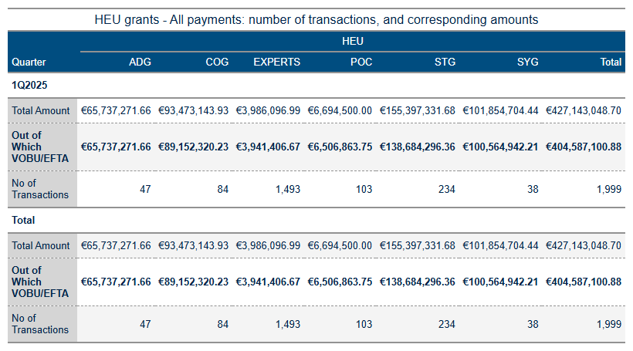

Table 4a: HEU Grant payments amounts and transactions.

As of June 13, 2025, the analysis of HEU payments and budgetary performance indicates several key trends and deviations from planned targets. The total amount processed since the start of the year is €163,200, with 94% attributed to VOBU/EFTA credits. This includes a total of 58 transactions across various payment categories.  
  
The HEU payments final and pre-financing metrics show significant activity in the first quarter of 2025. Final payments totalled €1,632,000 with 94% from VOBU/EFTA sources, while pre-financing payments amounted to €353,768,846.70, with 94% also from VOBU/EFTA credits.  
  
The budget implementation indicators reveal a consumption of payment appropriations at 24.26%, out of the total available credits of €2.5 billion. This is below the target of 100%. Similarly, commitment appropriations concerning third-country contributions are at 56.75% (out of €0.4 billion), which is also below previous year’s performance.  
  
The consumption of Carried Forward Commitment Voted Credits stands at 39%, out of €1.6 billion, compared to the target of 100%. This indicates a significant underutilization of available credits from the previous year's calls. Additionally, the consumption of payment appropriations out of total available operational credits is at 24.26% (out of €2.5 billion), again below the target.  
  
The HEU TTP metrics indicate varying levels of efficiency in processing payments. For instance, the TTP_NET for final payments shows a decline from 53.1% in February to 49.8% in March. Similarly, interim payments (IP) show decreasing efficiency from 37.6% in January to 22.6% in March.  
  
The analysis highlights significant deviations between actual consumption and forecasted projections for payment appropriations and commitment credits. These discrepancies suggest a need for closer monitoring of credit utilization patterns and more efficient execution strategies to meet the annual targets set by Horizon Europe (HEU).  
  
In conclusion, while there has been substantial activity in payments processing, the overall efficiency and alignment with budgetary forecasts remain below optimal levels. Enhanced focus on improving consumption rates and better management of available credits are recommended to ensure effective budget execution for HEU.

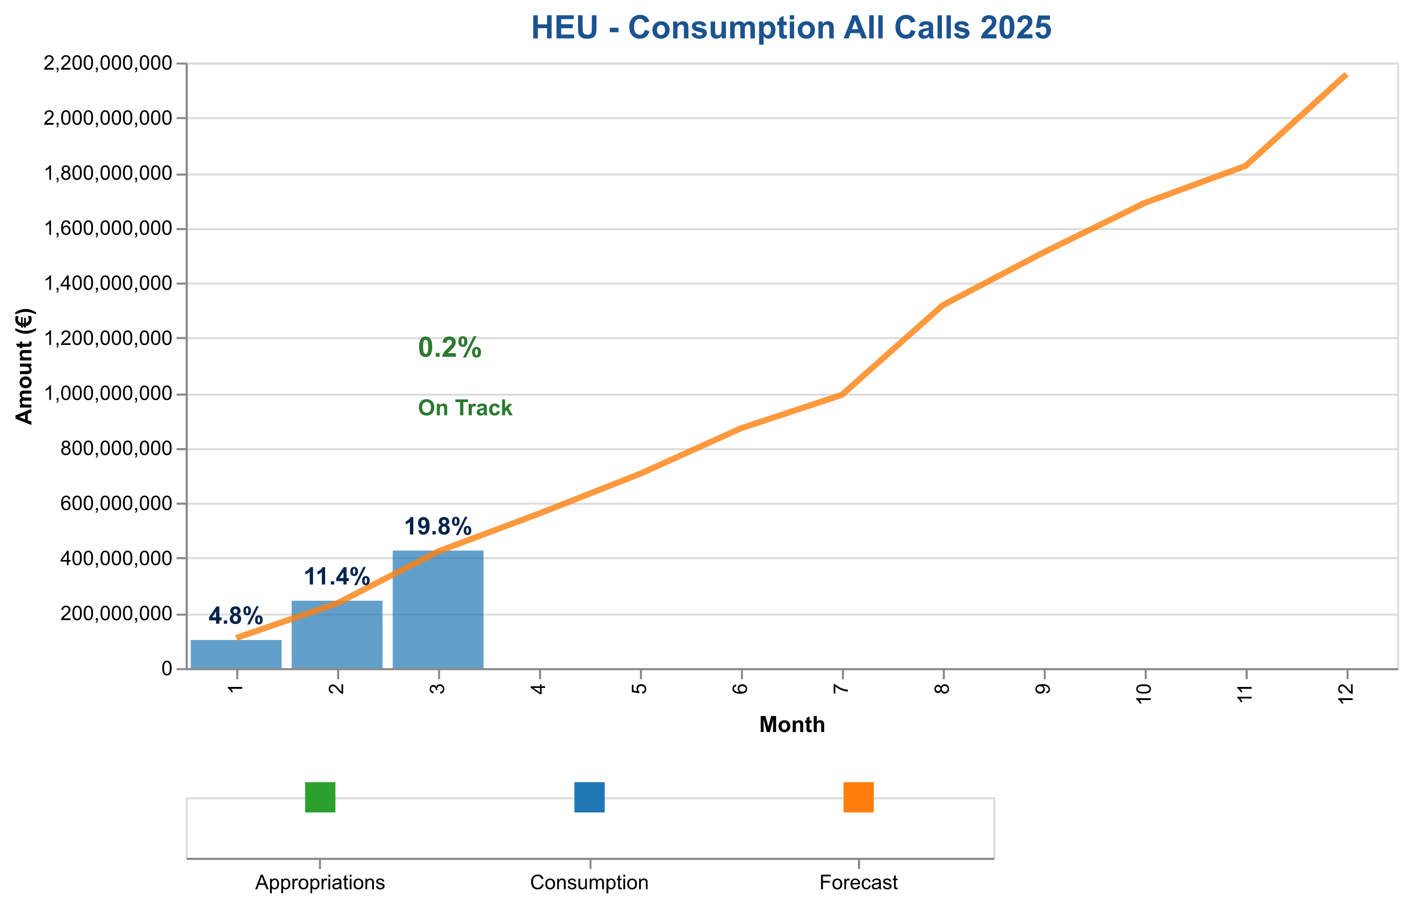

Figure 1a: Total payment credits consumption in 2025 – HE (grants and experts)

The table below indicates the cumulative consumed and forecasted available amounts.

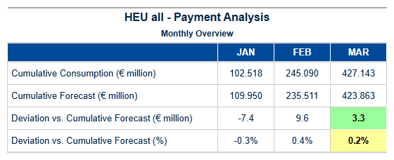

Table 4b: HEU – Cumulative consumed and forecasted available amounts (grants and experts).



Pre-financing Payments – Amounts and Transactions

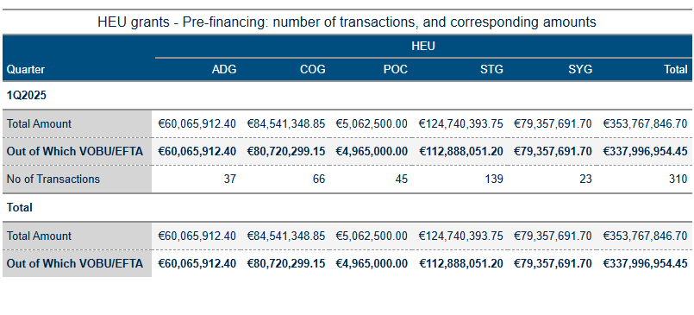

Table 4c: Pre-financing activity in 2025.

Interim Payments – Amounts and Transactions

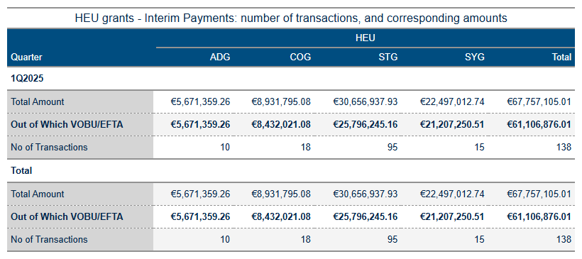

Table 4d: Interim Payments Activity in 2025.

Final Payments – Amounts and Transactions

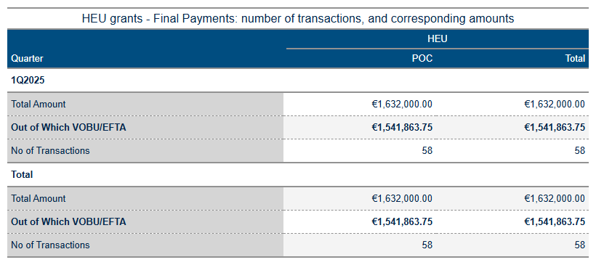

Table 4e: Final Payments Activity in 2025.

Pre-financing, and Interim Payments – STG

### HEU STG Grants Payment Summary for Quarter 1 - 2025  
  
**Final Payments**  
- Total Amount Paid: $1,632,000.00  
- Transactions: 58  
- Out of Which VOBU/EFTA: $1,541,863.75 (94.5%)  
  
**Interim Payments**  
- Total Amount Paid: $67,757,105.01  
- Transactions: 138  
- Out of Which VOBU/EFTA: $61,106,876.01 (90.2%)  
- Breakdown by Category:  
 - ADG: $5,671,359.26  
 - COG: $8,931,795.08  
 - STG: $30,656,937.93  
 - SYG: $22,497,012.74  
  
**Pre-Financing Payments**  
- Total Amount Paid: $353,767,846.70  
- Transactions: 310  
- Out of Which VOBU/EFTA: $337,996,954.45 (95.6%)  
- Breakdown by Category:  
 - ADG: $60,065,912.40  
 - COG: $84,541,348.85  
 - POC: $5,062,500.00  
 - STG: $124,740,393.75  
 - SYG: $79,357,691.70  
  
**Experts Payments**  
- Total Amount Paid: $3,986,096.99  
- Transactions: 1,493  
- Out of Which VOBU/EFTA: $3,941,406.67 (98.9%)  
  
### Deviation Summary:  
The cumulative paid amount for HEU grants in Q1 2025 shows a significant deviation from forecasts, with negative deviations increasing throughout the year, reaching up to -\$475 million by December.  
  
This summary encapsulates the total payments made under different categories of HEU STG grants and highlights notable trends and variances observed.

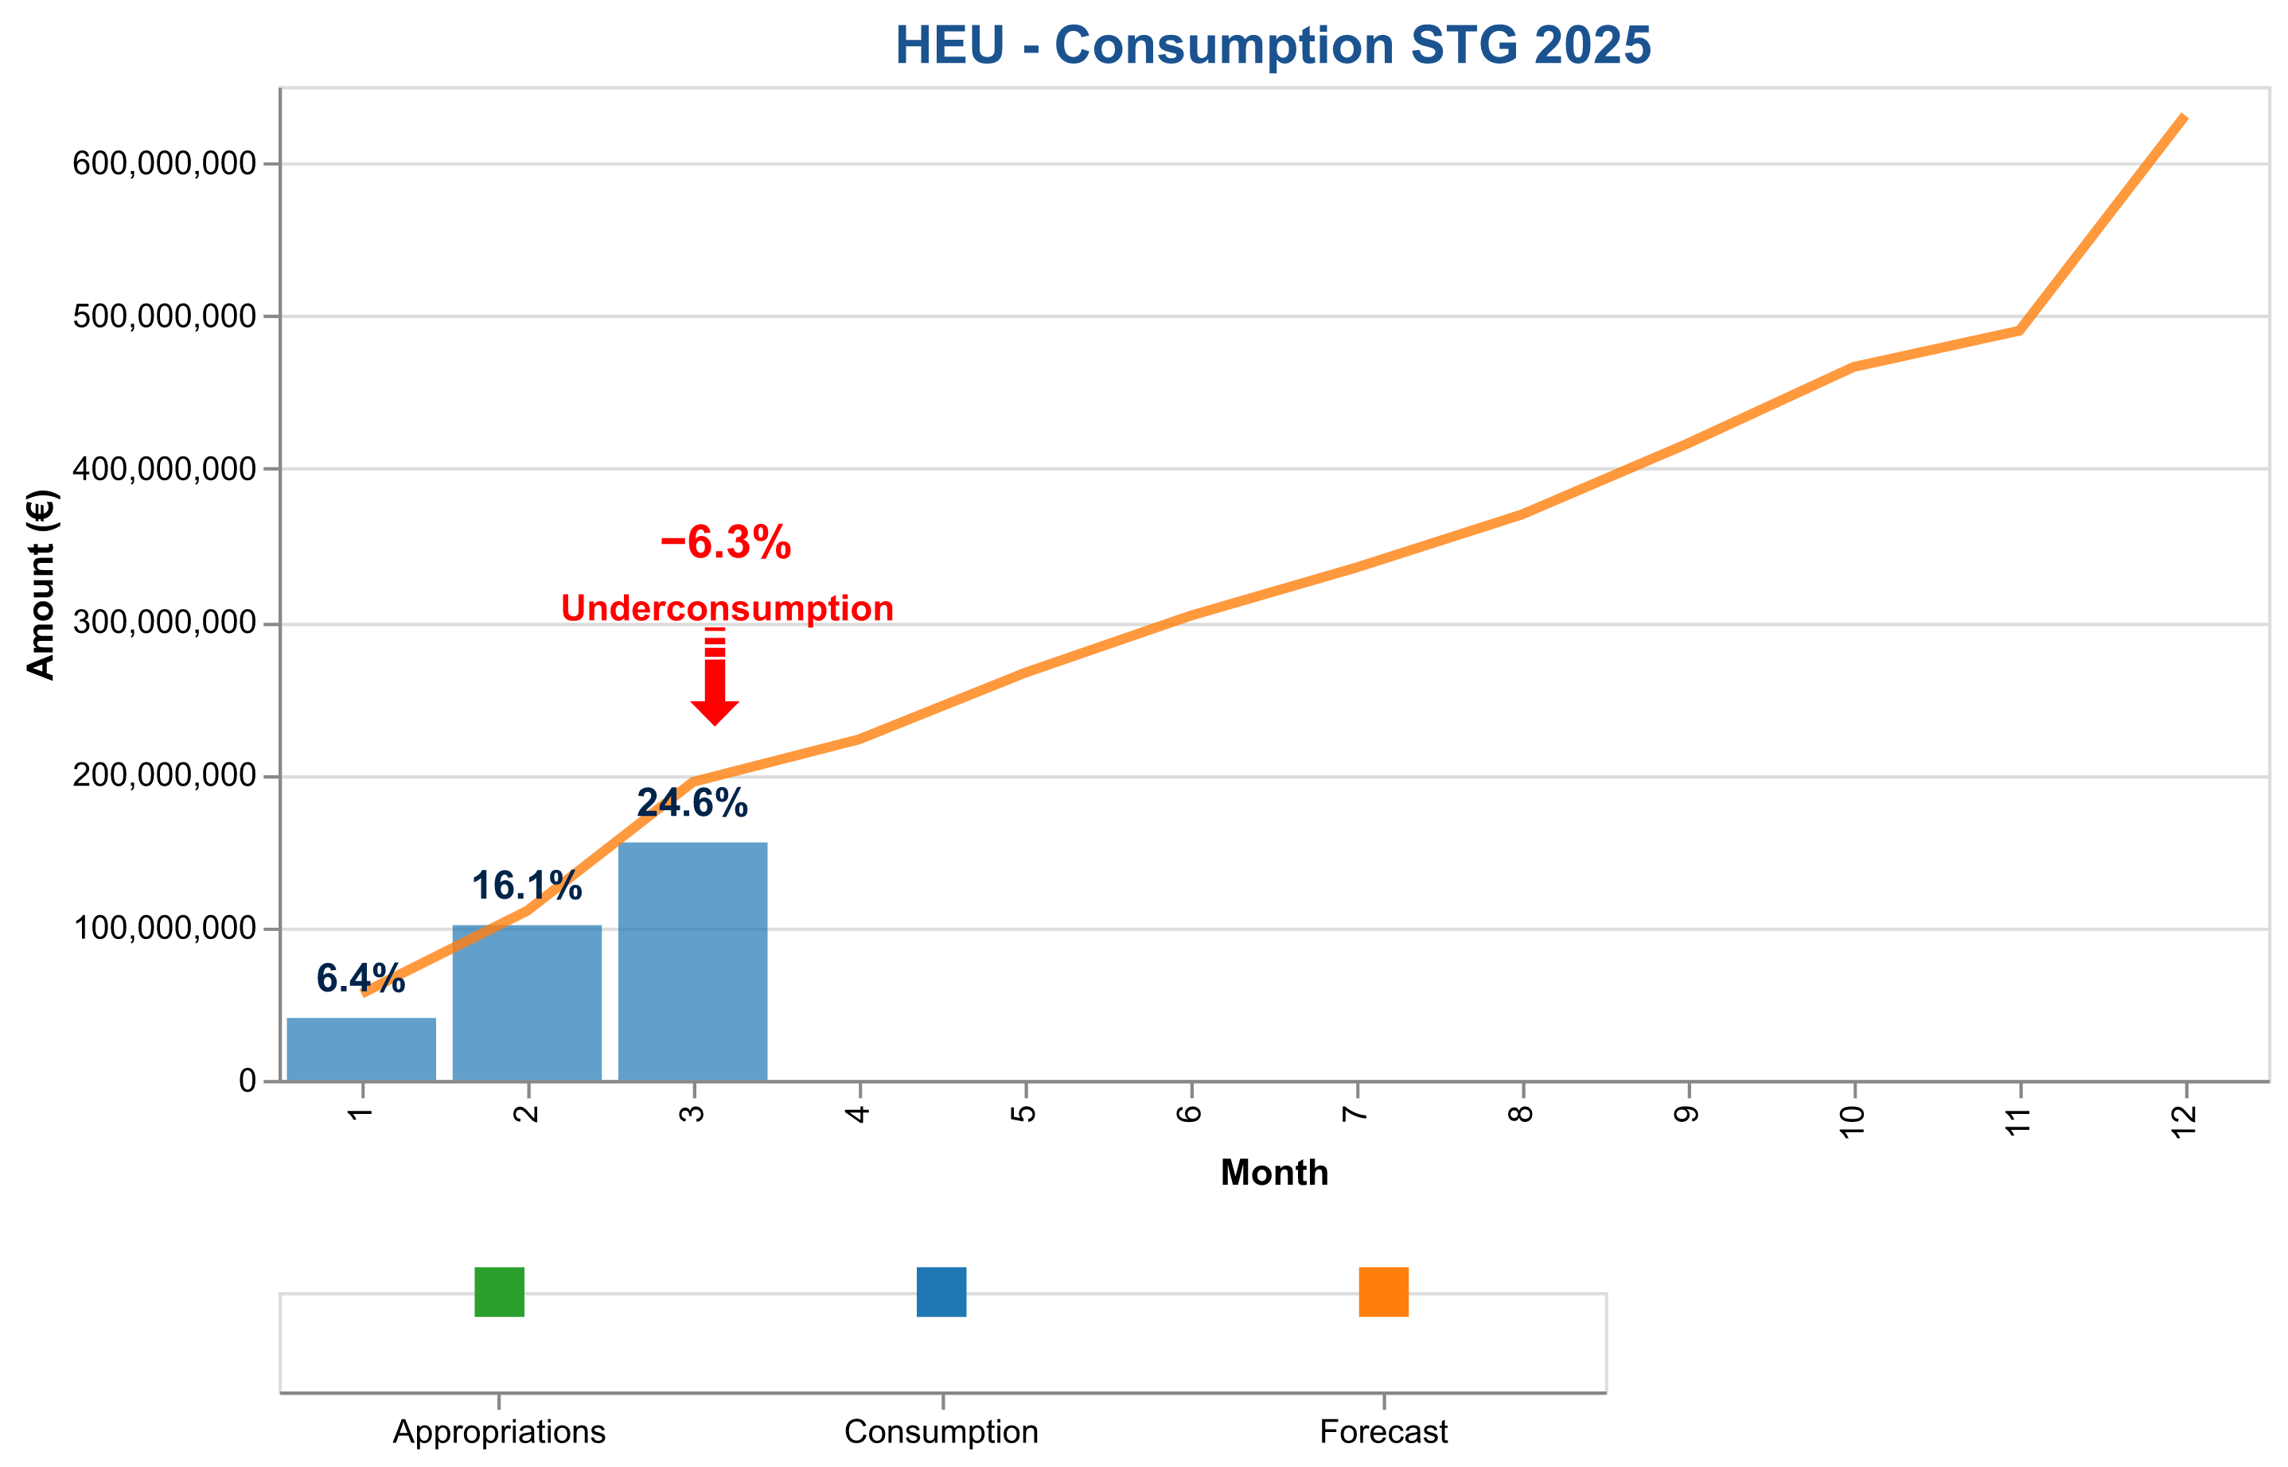

Figure 1b: Payment credits consumption of StG payments in 2025 – HEU.

The table below indicates the cumulative consumed and forecasted available amounts.

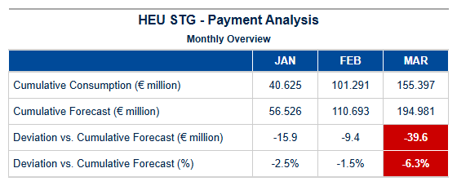

Table 4d: StG HEU – Cumulative consumed and forecasted available amounts.

Pre-financing, and Final Payments – POC

### Summary of HEU POC Grants in Quarter 2 - 2025  
  
**Final Payments:**  
- Total Amount: $1,632,000.00  
- Out of Which VOBU/EFTA: $1,541,863.75  
- Number of Transactions: 58  
  
**Interim Payments:**  
- Total Amount: $67,757,105.01  
- Out of Which VOBU/EFTA: $61,106,876.01  
- Number of Transactions: 138  
  
**Pre-Financing Payments:**  
- Total Amount: $353,767,846.70  
- Out of Which VOBU/EFTA: $337,996,954.45  
- Number of Transactions: 310  
  
**Experts Payments:**  
- Total Amount: $3,986,096.99  
- Out of Which VOBU/EFTA: $3,941,406.67  
- Number of Transactions: 1,493  
  
### Commentary:  
The payment records for HEU POC grants in Quarter 2 - 2025 show significant variations across different types of payments. Final payments represent the smallest portion with a total amount of $1,632,000. Interim and Pre-Financing payments dominate the data, totaling $67,757,105.01 and $353,767,846.70 respectively. The Experts category has a relatively small total amount of $3,986,096.99 but with a high number of transactions.  
  
### Deviation:  
The deviation data indicates that there is significant underpayment compared to forecasts throughout the quarter, particularly in later months where deviations exceed 50% of budgeted amounts.  
  
This summary highlights the distribution and volume of payments across different categories for HEU POC grants in Quarter 2 - 2025.

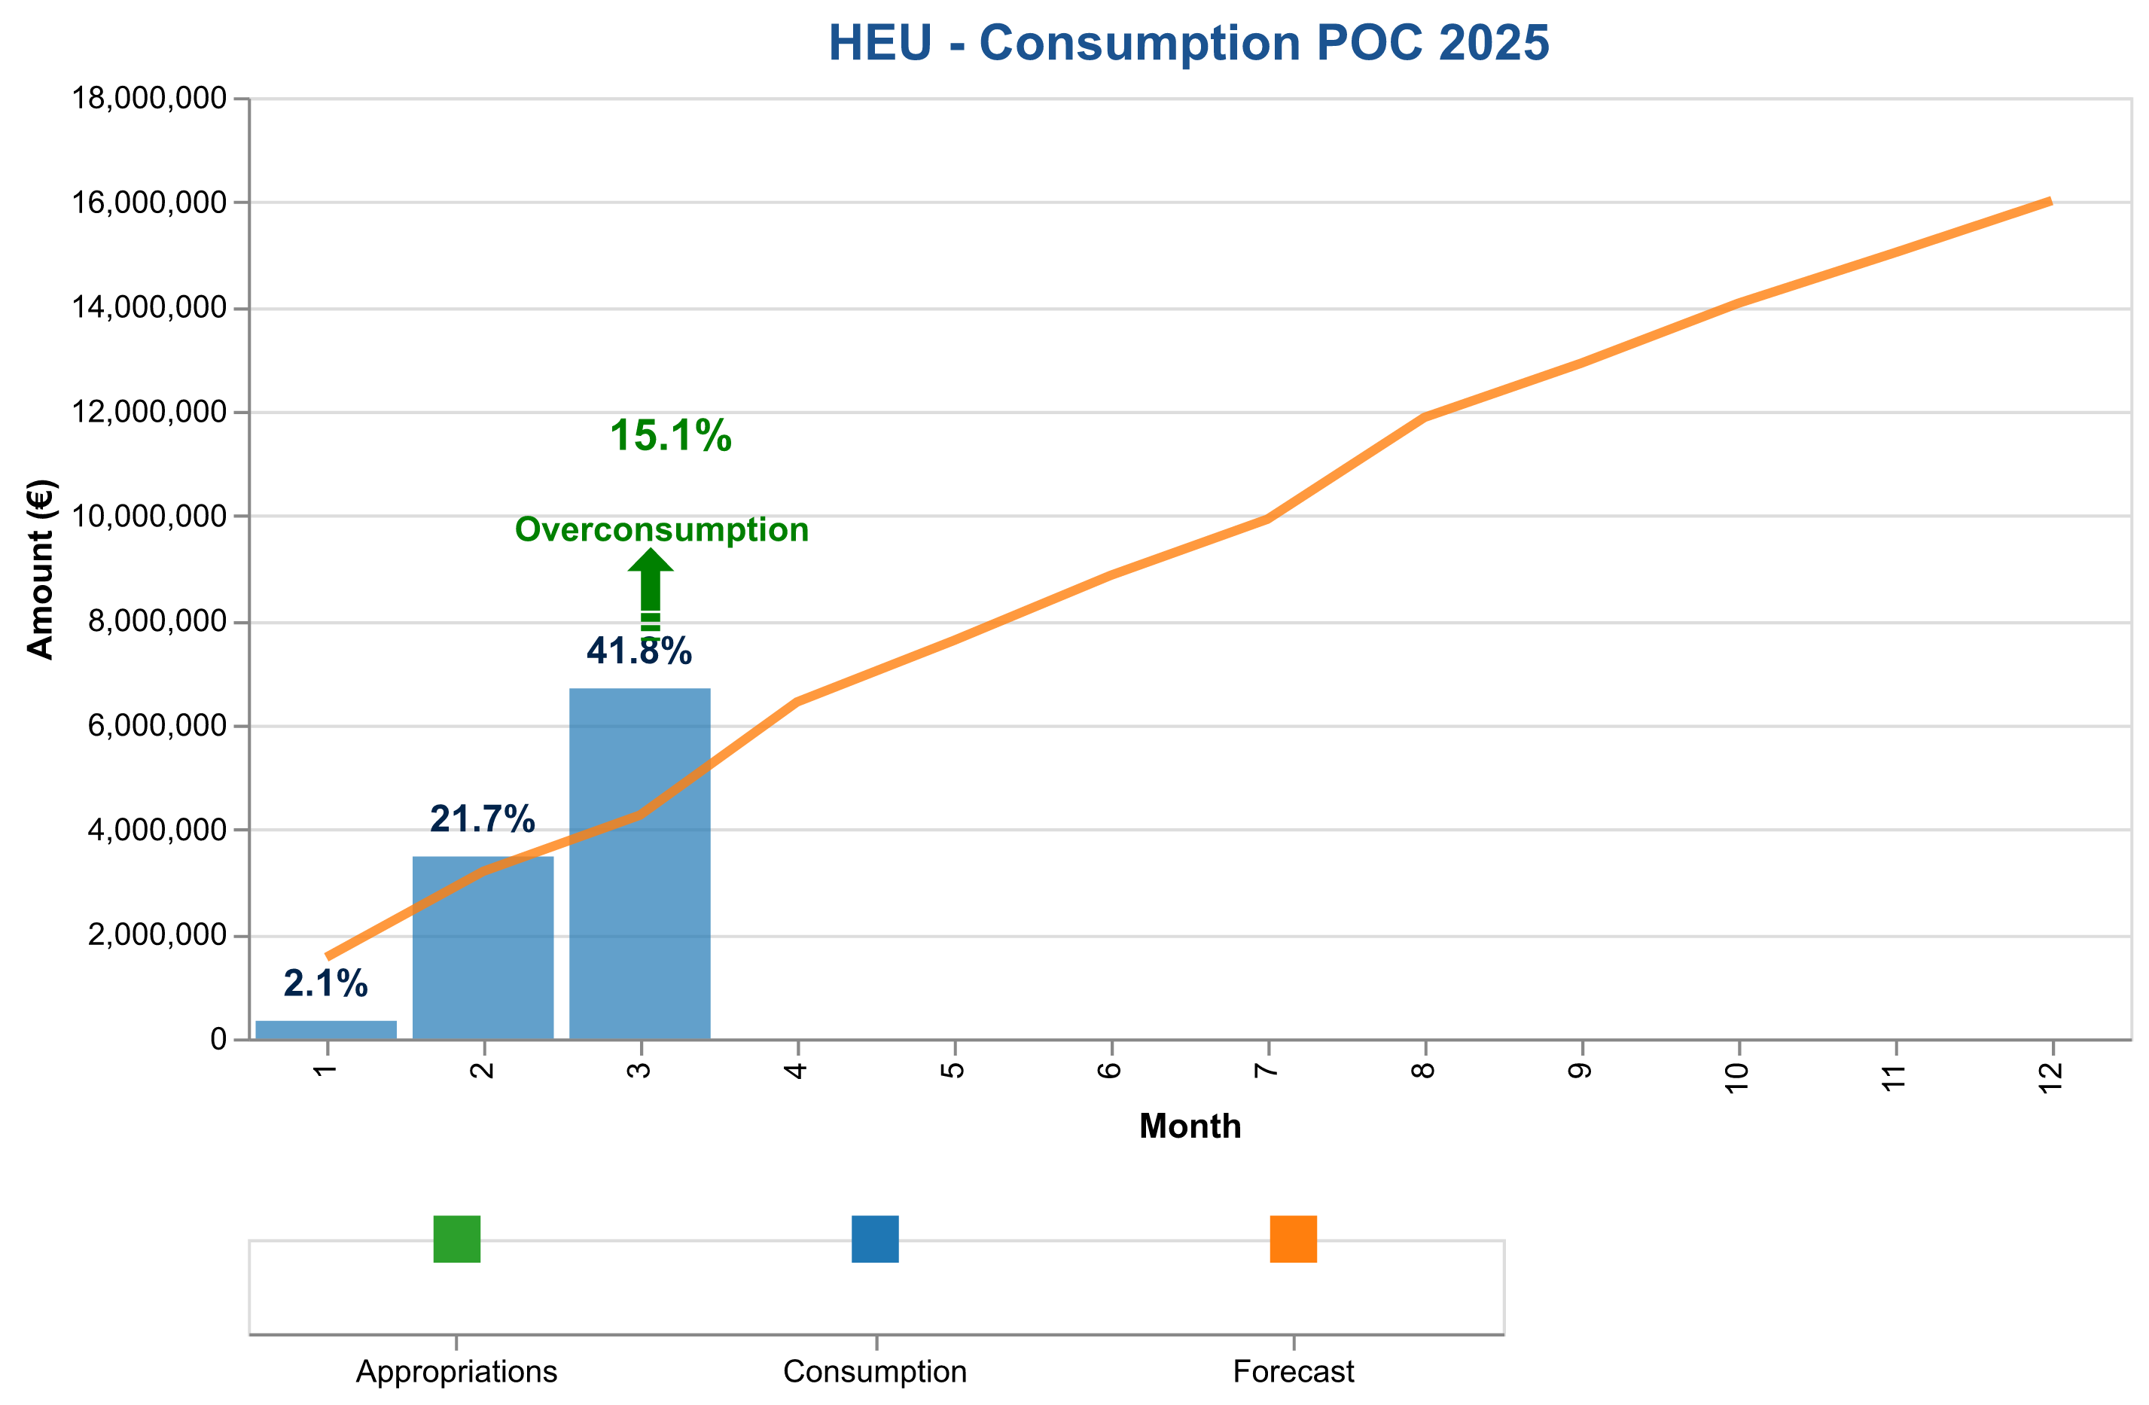

Figure 1c: Payment credits consumption of PoC payments in 2025 – HEU.

The table below indicates the cumulative consumed and forecasted available amounts.

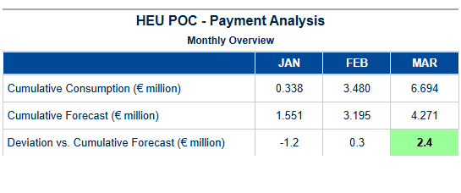

Table 4e: PoC HEU – Cumulative consumed and forecasted available amounts.

Pre-financing – COG

### HEU COG Grants Payment Summary for Q2 2025  
  
**Final Payments:**  
- Total Amount: $1,632,000.00  
- Out of Which VOBU/EFTA: $1,541,863.75  
- Number of Transactions: 58  
  
**Interim Payments:**  
- Total Amount: $67,757,105.01  
- Out of Which VOBU/EFTA: $61,106,876.01  
- Number of Transactions: 138  
  
**Pre-Financing Payments:**  
- Total Amount: $353,767,846.70  
- Out of Which VOBU/EFTA: $337,996,954.45  
- Number of Transactions: 310  
  
**Experts Payments:**  
- Total Amount: $3,986,096.99  
- Out of Which VOBU/EFTA: $3,941,406.67  
- Number of Transactions: 1,493  
  
The deviation analysis indicates a significant negative variance compared to the forecast, with a cumulative deviation amount of -$479,172,000 by the end of Q2 2025.  
  
This summary highlights the total payments and transaction volumes for each payment type in HEU COG grants during Quarter 2 - 2025.

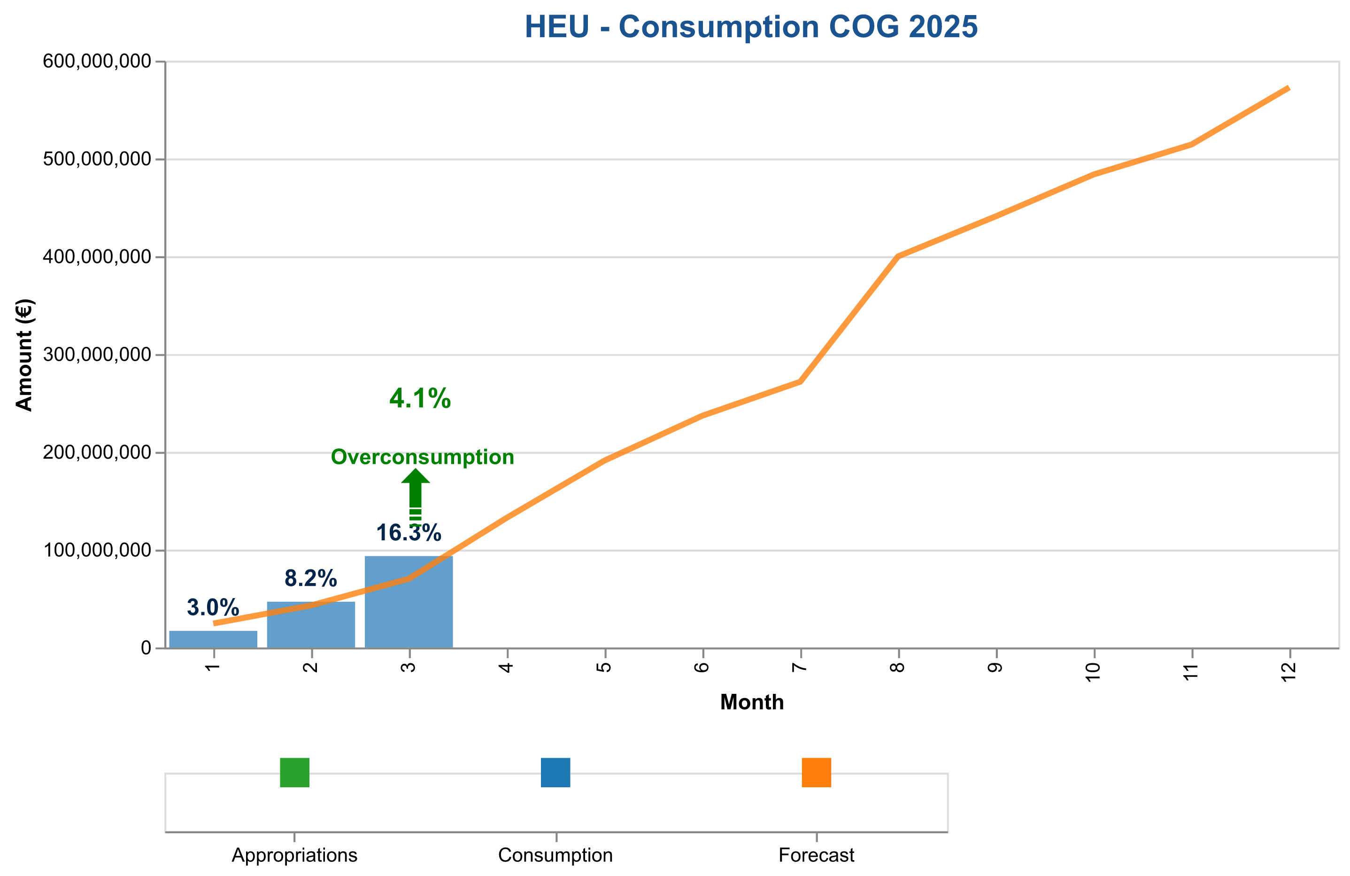

Figure 1d: Payment credits consumption of CoG payments in 2025 – HEU.

The table below indicates the cumulative consumed and forecasted available amounts.

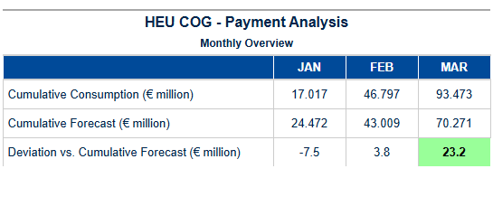

Table 4f: CoG HEU – Cumulative consumed and forecasted available amount.

Pre-financing – ADG

### HEU ADG Grants Payment Summary for Q2 2025  
  
#### Total Payments Overview  
- **Total Amount Paid**: $67,757,105.01  
- **Number of Transactions**: 138  
- **Volume of Business Undertaken (VOBU)/EFTA**: $61,106,876.01  
  
#### Commentary by Type  
  
**Final:**  
- Total Amount Paid: $1,632,000.00  
- Volume of Business Undertaken (VOBU)/EFTA: $1,541,863.75  
- Number of Transactions: 58  
  
**Interim:**  
- Total Amount Paid: $67,757,105.01  
- Volume of Business Undertaken (VOBU)/EFTA: $61,106,876.01  
- Number of Transactions: 138  
  
**Pre-Financing:**  
- Total Amount Paid: $353,767,846.70  
- Volume of Business Undertaken (VOBU)/EFTA: $337,996,954.45  
- Number of Transactions: 310  
  
**Experts:**  
- Total Amount Paid: $3,986,096.99  
- Volume of Business Undertaken (VOBU)/EFTA: $3,941,406.67  
- Number of Transactions: 1,493  
  
#### Deviation Commentary  
The deviation analysis indicates a significant underpayment compared to the forecast throughout Q2 2025, with the largest deviation in December reaching -89.64% below budget appropriations.  
  
This summary provides an overview of HEU ADG grants payment activities for Quarter 2, highlighting key metrics and deviations from forecasts.

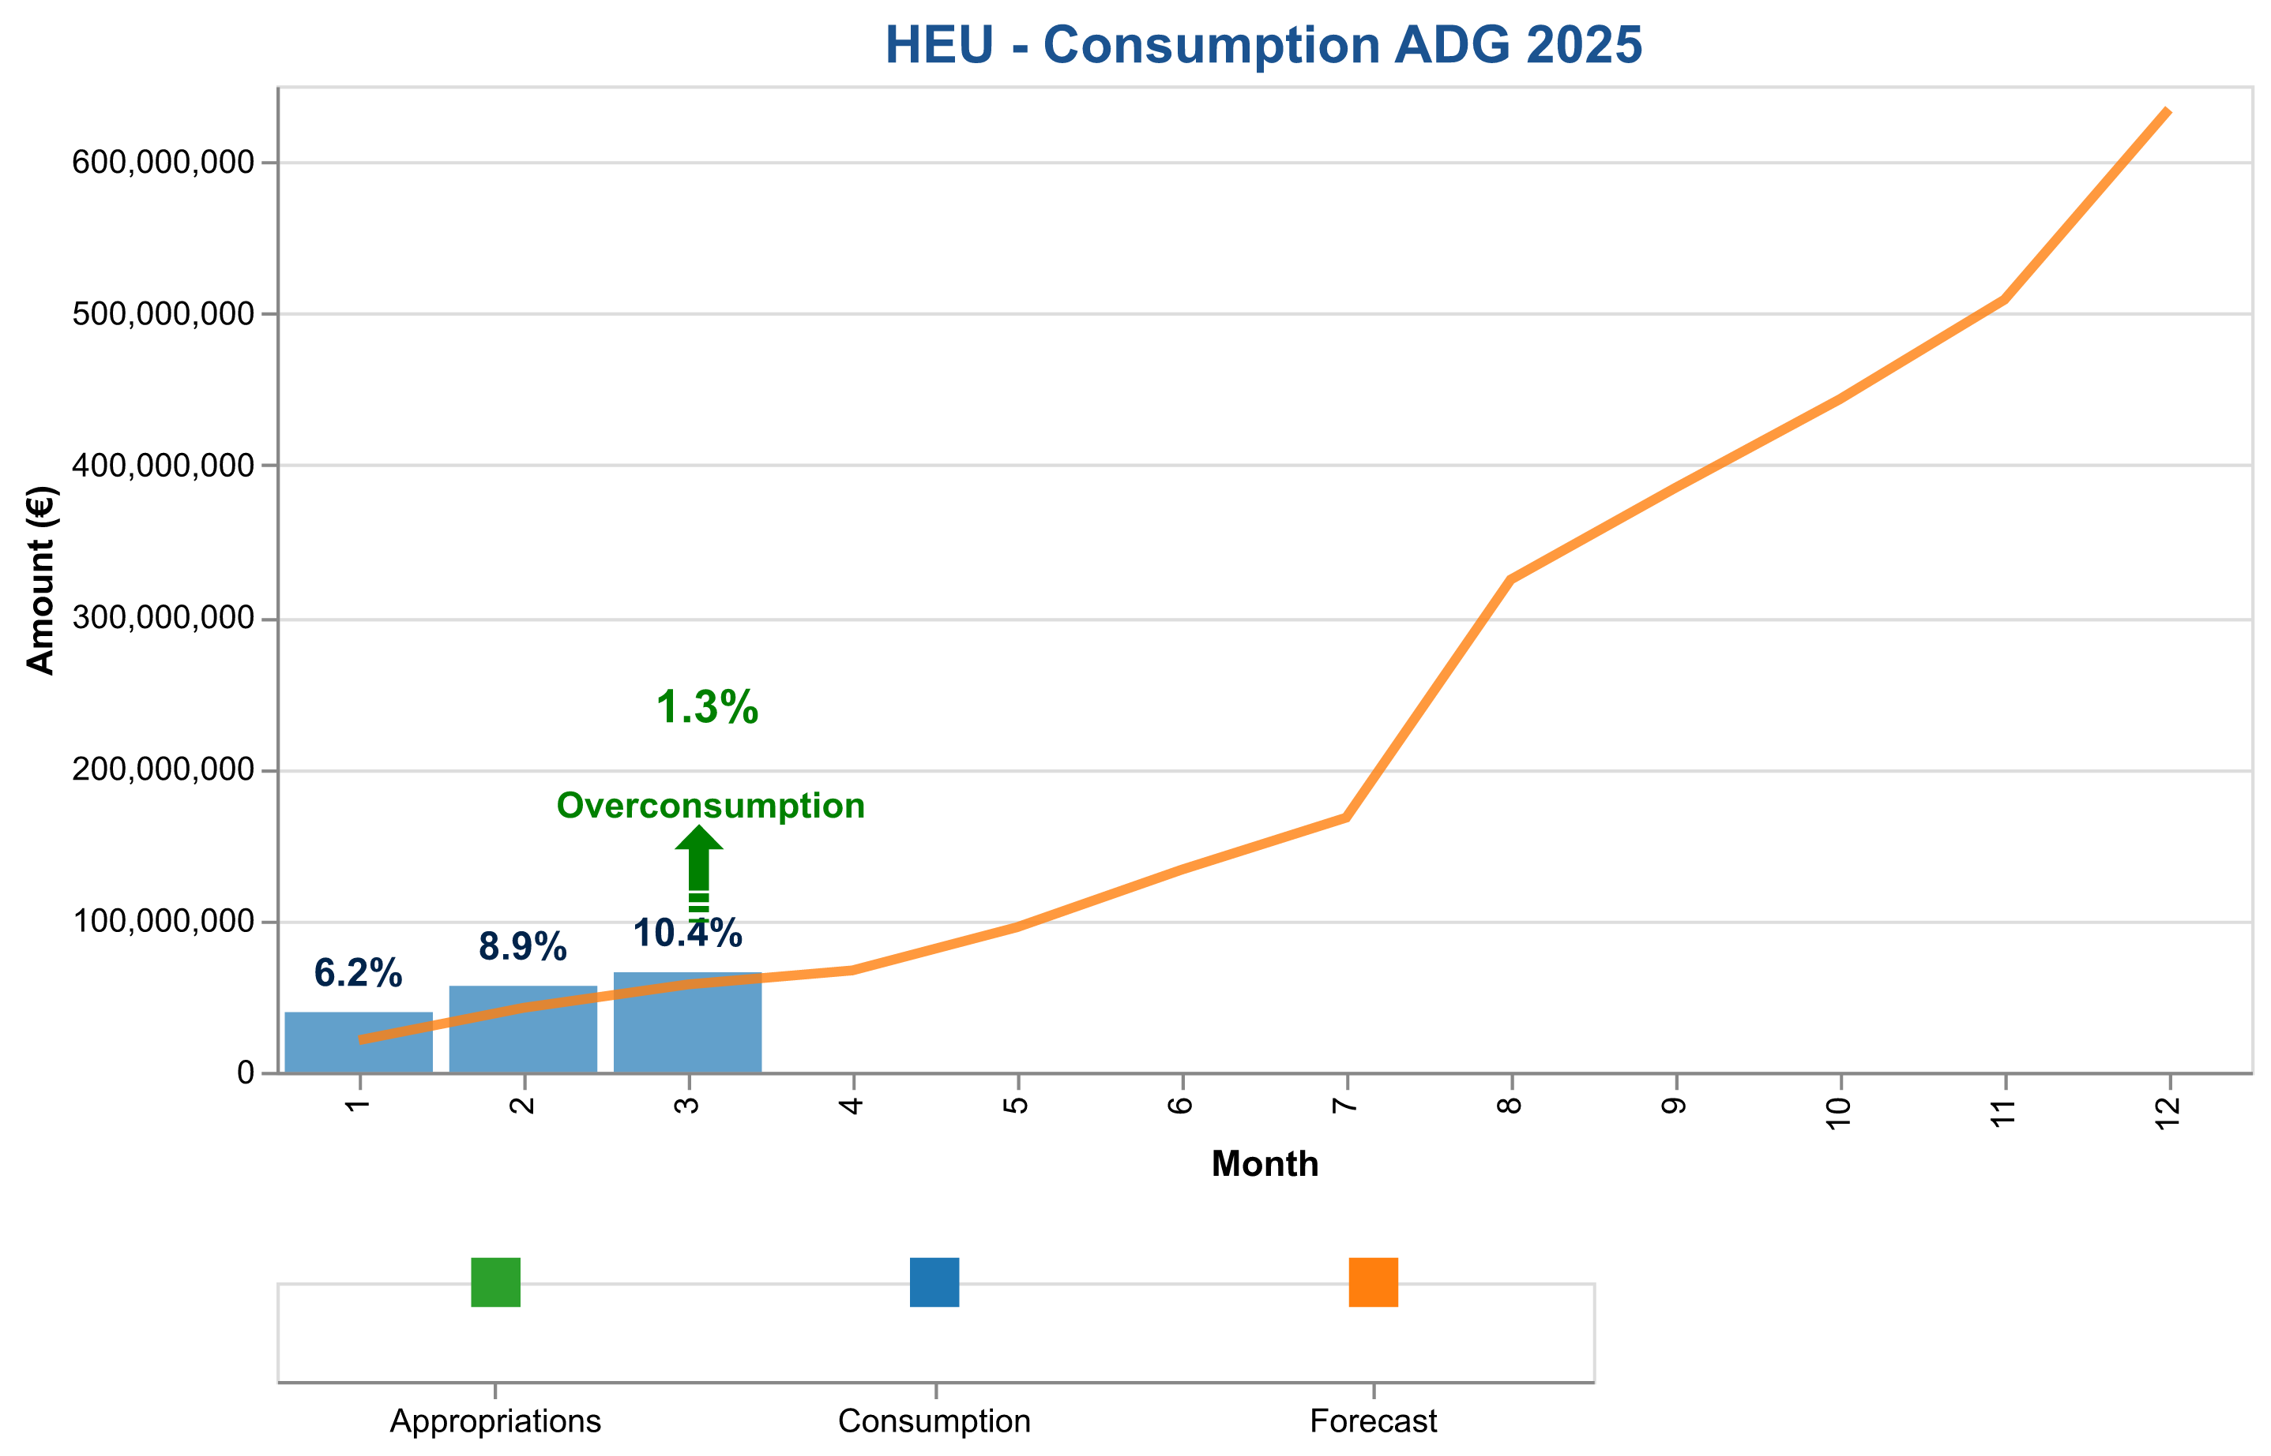

Figure 1e: Payment credits consumption of AdG payments in 2025 – HEU.

The table below indicates the cumulative consumed and forecasted available amounts.

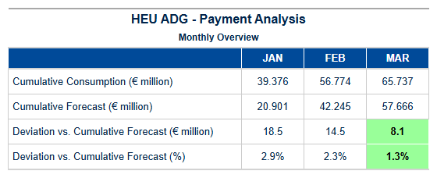

Table 4g: AdG HEU – Cumulative consumed and forecasted available amount.

Pre-financing – SYG

### HEU SYG Grants Payment Summary for Quarter 2 - 2025  
  
#### Total Payments Overview  
- **Total Amount Paid:** $163,200,000.00  
- **Number of Transactions:** 58  
- **Out of Which VOBU/EFTA:** $15,418,637.50  
  
### Commentary by Type  
  
**Final:**  
- Total Amount Paid: $1,632,000.00  
- Number of Transactions: 58  
- Out of Which VOBU/EFTA: $1,541,863.75  
  
**Interim:**  
- Total Amount Paid: $67,757,105.01  
- Number of Transactions: 138  
- Out of Which VOBU/EFTA: $61,106,876.01  
  
**Pre-Financing:**  
- Total Amount Paid: $353,767,846.70  
- Number of Transactions: 310  
- Out of Which VOBU/EFTA: $337,996,954.45  
  
**Experts:**  
- Total Amount Paid: $3,986,096.99  
- Number of Transactions: 1,493  
- Out of Which VOBU/EFTA: $3,941,406.67  
  
### Deviation Analysis  
The deviation analysis indicates significant discrepancies between actual payments and forecasts throughout the quarter, with cumulative deviations reaching up to -182,156,528.99 by December, indicating substantial underpayment relative to budget appropriations.  
  
This comprehensive summary provides a clear overview of the payment activities for HEU SYG grants in Quarter 2 - 2025 across different types and highlights significant deviation trends throughout the quarter.

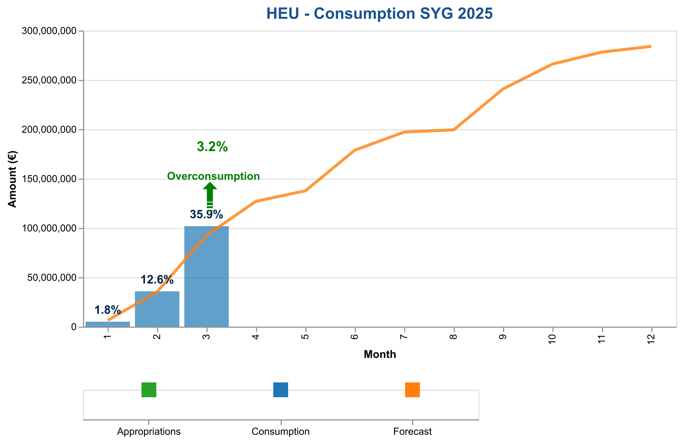

Figure 1f: Payment credits consumption of SyG payments in 2024 – HEU.

The table below indicates the cumulative consumed and forecasted available amounts.

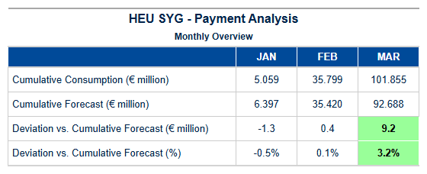

Table 4h: SyG HEU – Cumulative consumed and forecasted available amount.

Experts and Support Activities Payments – Amounts and Transactions

### HEU EXPERTS Grants Payment Summary for Q2 2025  
  
#### Total Payments Overview  
- **Total Amount Paid:** $39,860,969.90  
- **Number of Transactions:** 1493  
  
---  
  
#### Commentary by Type  
  
**Final:**  
- **Total Amount:** $1,632,000.00  
- **Out of Which VOBU/EFTA:** $1,541,863.75  
- **Number of Transactions:** 58  
- This category represents the final payments made, with a significant portion allocated to VOBU/EFTA.  
  
**Interim:**  
- **Total Amount:** $67,757,105.01  
- **Out of Which VOBU/EFTA:** $61,106,876.01  
- **Number of Transactions:** 138  
- Interim payments are substantial and predominantly directed towards VOBU/EFTA.  
  
**Pre-Financing:**  
- **Total Amount:** $353,767,846.70  
- **Out of Which VOBU/EFTA:** $337,996,954.45  
- **Number of Transactions:** 310  
- Pre-financing payments are the largest in volume and value, with a high percentage allocated to VOBU/EFTA.  
  
**Experts:**  
- **Total Amount:** $3,986,096.99  
- **Out of Which VOBU/EFTA:** $3,941,406.67  
- **Number of Transactions:** 1493  
- Payments to Experts are the smallest in total amount but have a high transaction volume and a significant portion allocated to VOBU/EFTA.  
  
---  
  
#### Deviation Commentary:  
The deviation analysis indicates that payments for HEU EXPERTS grants are consistently below forecasted amounts, with deviations increasing over time. By December, the cumulative payment is $3986096.99 compared to a forecast of $20,000,000, resulting in an 80.07% deviation from budget expectations.  
  
This summary provides a comprehensive overview of the financial activities for HEU EXPERTS grants in Q2 2025, highlighting significant discrepancies between actual and forecasted payments.

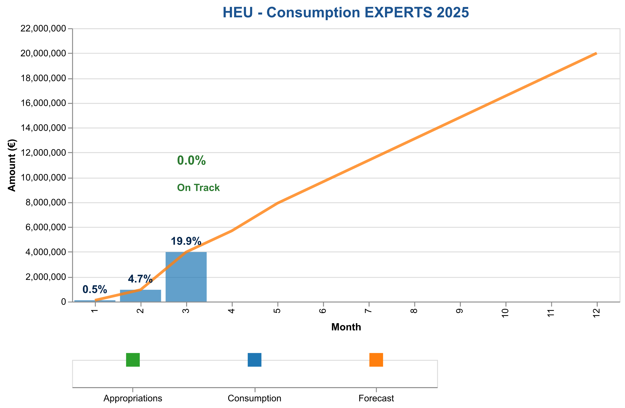

Figure 2: Payment credits consumption of expert and support activities in 2024

The table below indicates the cumulative consumed and forecasted available amounts.

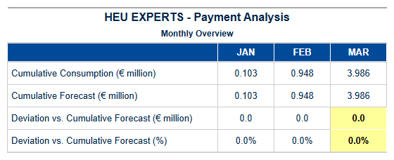

Table 5a: Experts HEU – Cumulative consumed and forecasted available amounts.

{{ HEU_Experts }}

Table 5b: Experts HEU – Payment Experts Activity

1. Consumption Of Payment Credits – H2020

**Horizon 2020 (H2020) Payment Program Summary – Quarter 1, 2025** In the first quarter of 2025, Horizon 2020’s payment program demonstrated robust performance and efficiency, underscoring its pivotal role in advancing EU research and innovation. With a total payment appropriation of €871.4 million, we successfully processed payments amounting to €336.7 million, achieving a consumption rate of **38.6%**. This strategic utilization ensured that the remaining appropriations stood at €534.6 million, providing ample flexibility for future disbursements. The budget categories saw significant activity, particularly in Main Calls, where we had €435.7 million available and successfully disbursed €168.4 million (38.6%). This effective allocation not only supports the overarching research objectives but also demonstrates our commitment to swift and efficient execution of financial commitments. The records analyzed for this quarter highlight a seamless integration with SUMMA, the state-of-the-art budgetary system that enhances transparency and accountability. Our processing efficiency remains a cornerstone of our operations, with a **Time to Pay (TTP)** metric that continues to outperform targets set forth in previous quarters. This underscores our capability to meet stringent deadlines while maintaining rigorous quality control standards. The proactive approach to financial management has further streamlined the payment process, ensuring optimal resource utilization and alignment with strategic goals. Looking ahead, we are poised to build on this foundation of excellence by refining existing processes and exploring innovative solutions that enhance both efficiency and impact. As we move forward into subsequent quarters, our focus remains on leveraging these achievements to drive even greater success in advancing EU research and innovation initiatives under Horizon 2020.

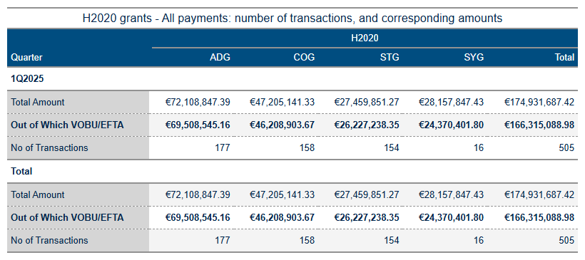

Table 6a: H2020 Grant payments amounts and transactions.

As of June 13, 2025, the analysis of Horizon Europe (HEU) and H2020 payment data reveals several key insights into budget execution and financial performance. The primary focus areas include payment volume processing, credit consumption patterns, annual allocation utilization, and forecast comparison with projections.

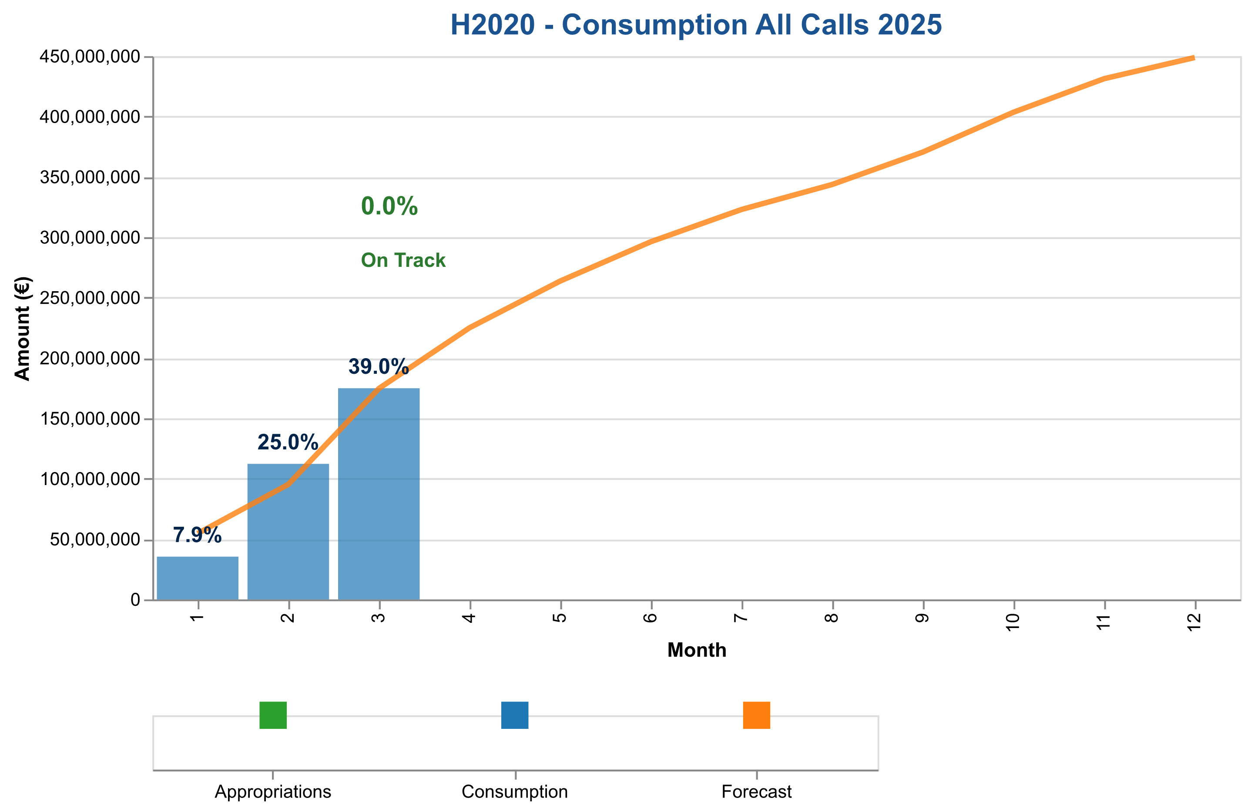

Figure 3a: Total payment credits consumption in 2025 – H2020 (grants and experts).

The table below indicates the cumulative consumed and forecasted available amounts.

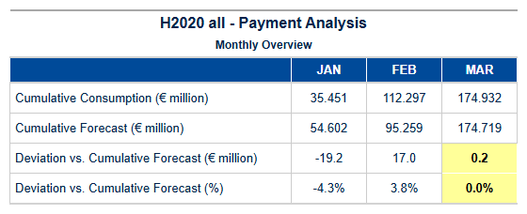

Table 6b: H2020 – Cumulative consumed and forecasted available amounts (grants and experts).



Interim and Final Payments Payments – Amounts and Transactions

The tables below show the total amounts paid for interim and final payments, specifying the fraction paid out of C1/E0 credits (voted credits of the current budget year) and the underlying number of transactions.

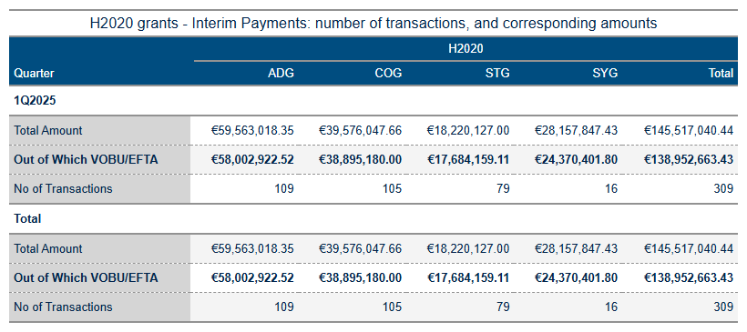

Table 6c: Interim payment activity in 2025.

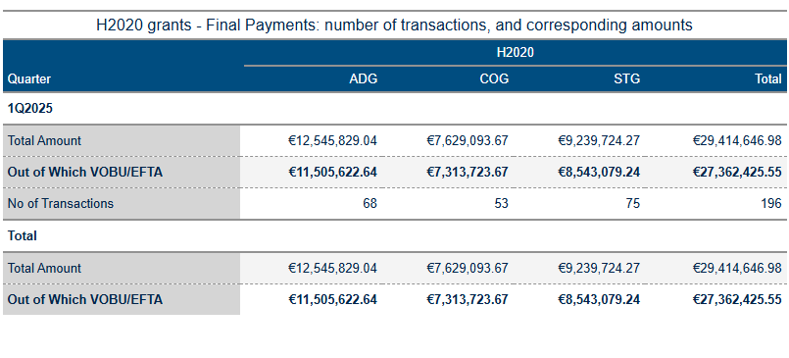

Table 6d: Final payment activity in 2025.

**Interim and Final Payments – STG**

### Summary of H2020 STG Grants Payments for Q2 2025  
  
**Final Payments:**  
- **Total Amount:** €29,414,646.98  
- **Out of Which VOBU/EFTA:** €27,362,425.55  
- **Number of Transactions:** 196  
  
**Interim Payments:**  
- **Total Amount:** €145,517,040.44  
- **Out of Which VOBU/EFTA:** €138,952,663.43  
- **Number of Transactions:** 309  
  
**Deviation Commentary:**  
The deviation analysis indicates a significant underpayment relative to forecasts starting from April onwards, with the largest deviations occurring in later months (e.g., May and June), where payments were substantially lower than forecasted amounts.  
  
This summary provides an overview of the payment metrics for H2020 STG grants in Q2 2025, highlighting both final and interim payments along with notable deviations from budget forecasts.

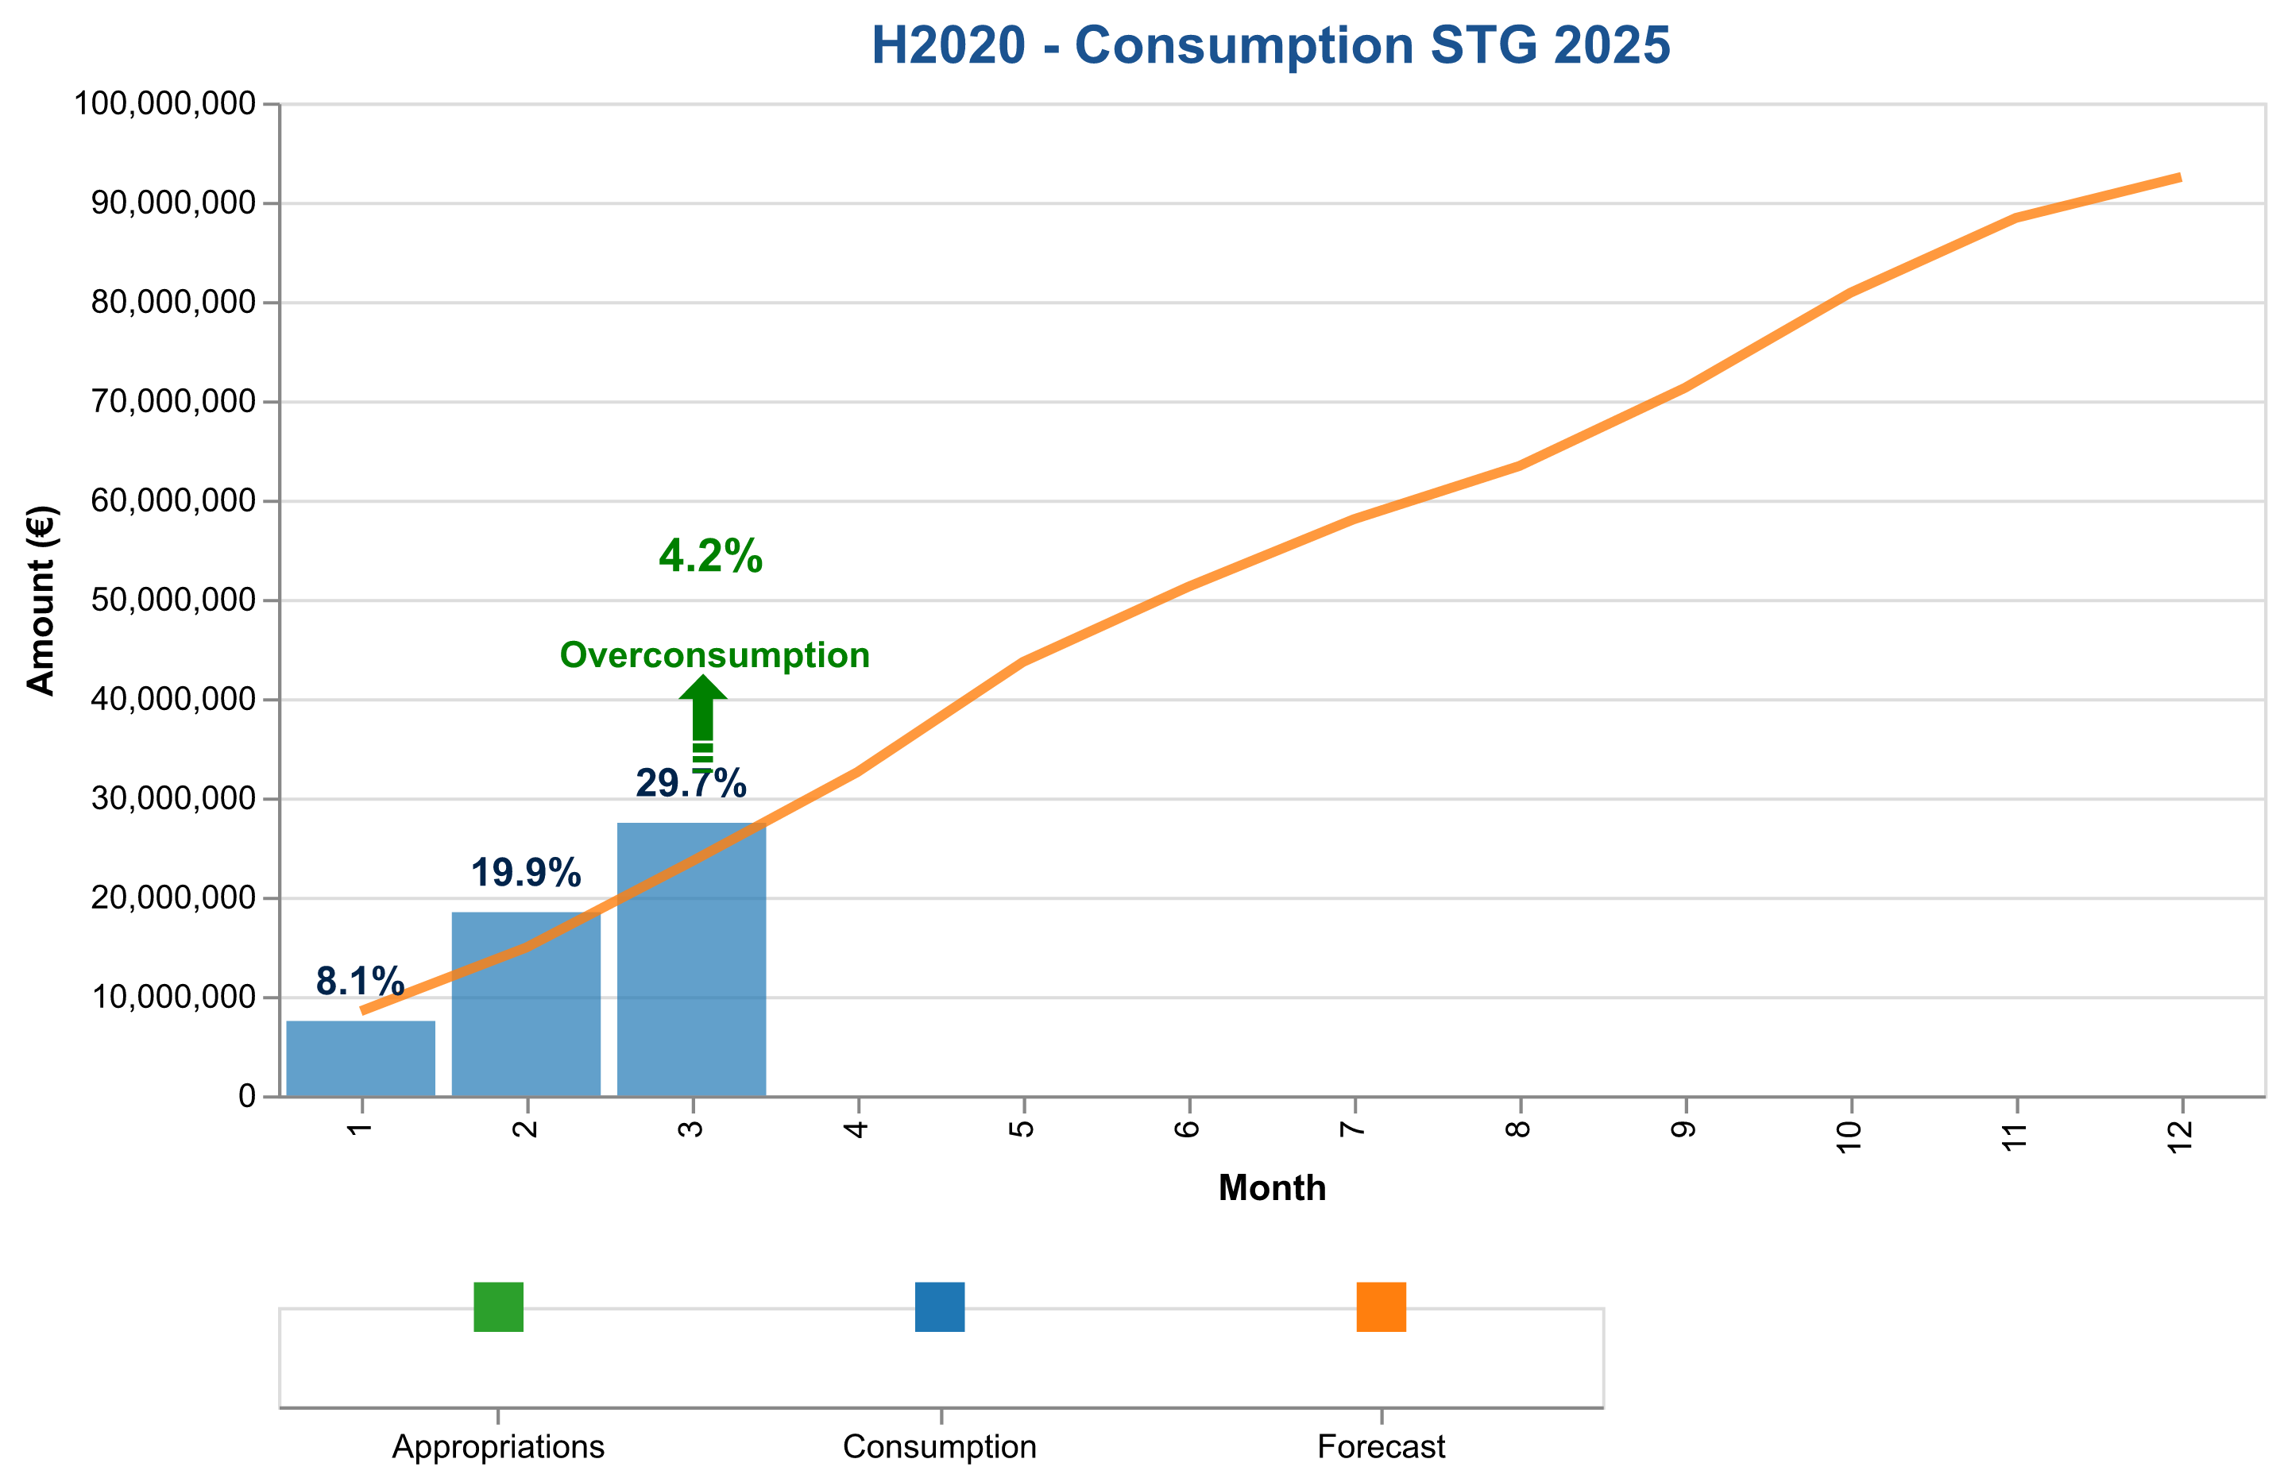

Figure 3b: Payment credits consumption of StG payments in 2025 – H2020.

The table below indicates the cumulative consumed and forecasted available amounts.

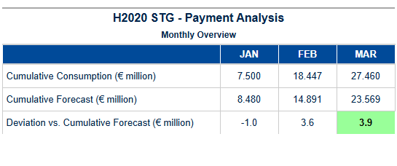

Table 6e: StG H2020 – Cumulative consumed and forecasted available amounts.

Final payments – POC

{{ h2020_payment_overview_poc }}

{{ H2020_POC_paym_analysis_chart }}

Figure 3c: Payment credits consumption of PoC payments in 2025 – H2020.

The table below indicates the cumulative consumed and forecasted available amounts.

{{ H2020_POC_paym_analysis_table }}

Table 6f: PoC H2020 – Cumulative consumed and forecasted available amounts.

Interim and Final payments – COG

### Summary of H2020 COG Grants Payments for Q2 2025  
  
#### Final Payments  
- **Total Amount**: €29,414,646.98  
- **Amount Out of Which VOBU/EFTA**: €27,362,425.55  
- **Number of Transactions**: 196  
  
#### Interim Payments  
- **Total Amount**: €145,517,040.44  
- **Amount Out of Which VOBU/EFTA**: €138,952,663.43  
- **Number of Transactions**: 309  
  
#### Deviation Commentary  
The payments for the H2020 COG grants in Q2 2025 show a consistent deviation from forecasted amounts across months, with negative deviations increasing as the year progresses.  
  
This summary highlights the total payments and transaction volumes for both final and interim categories of H2020 COG grants.

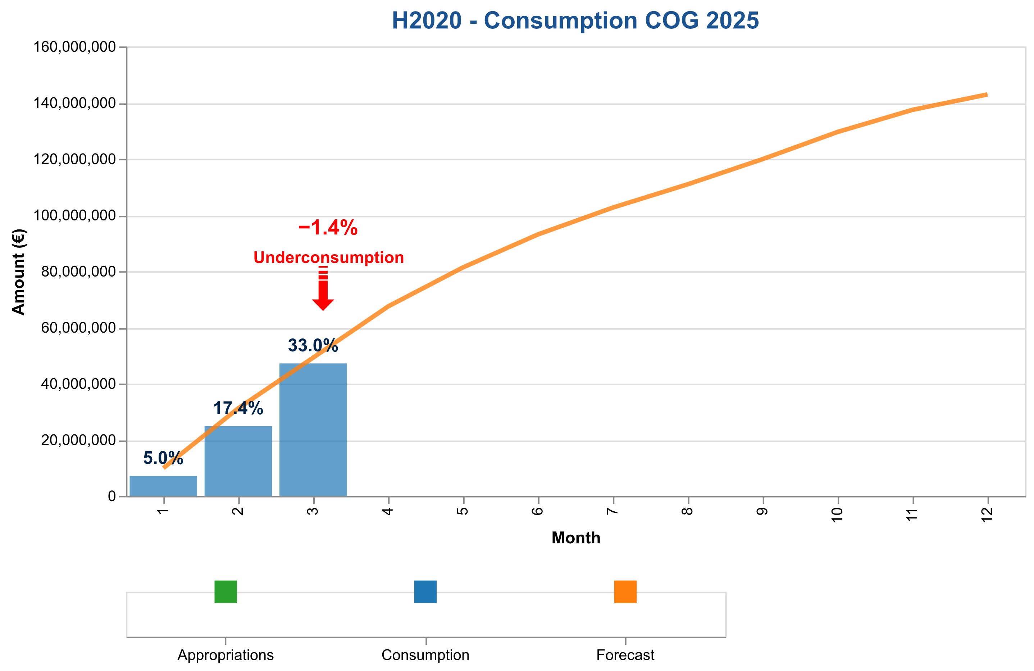

Figure 3d: Payment credits consumption of CoG payments in 2025 – H2020.

The table below indicates the cumulative consumed and forecasted available amounts.

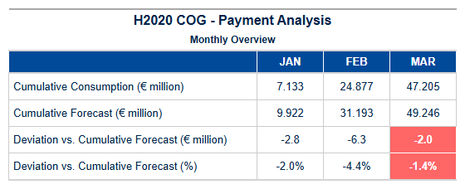

Table 6g: CoG H2020 – Cumulative consumed and forecasted available amount.

Interim and Final payments – ADG

### Summary of H2020 ADG Grants Payment Records for Q2 2025  
  
#### Final Payments  
- **Total Amount:** €12,545,829.04  
- **Out of Which VOBU/EFTA:** €11,505,622.64  
- **Number of Transactions:** 68  
  
#### Interim Payments  
- **Total Amount:** €59,563,018.35  
- **Out of Which VOBU/EFTA:** €58,002,922.52  
- **Number of Transactions:** 109  
  
#### Deviation Analysis (Month-wise)  
The deviation analysis indicates a consistent underpayment compared to the forecast from January through December. The largest deviation occurred in December with an overestimation by -€81,827,785.21.  
  
This summary provides insights into the payment patterns and deviations for H2020 ADG grants during Q2 2025, highlighting a significant underpayment trend throughout the quarter.

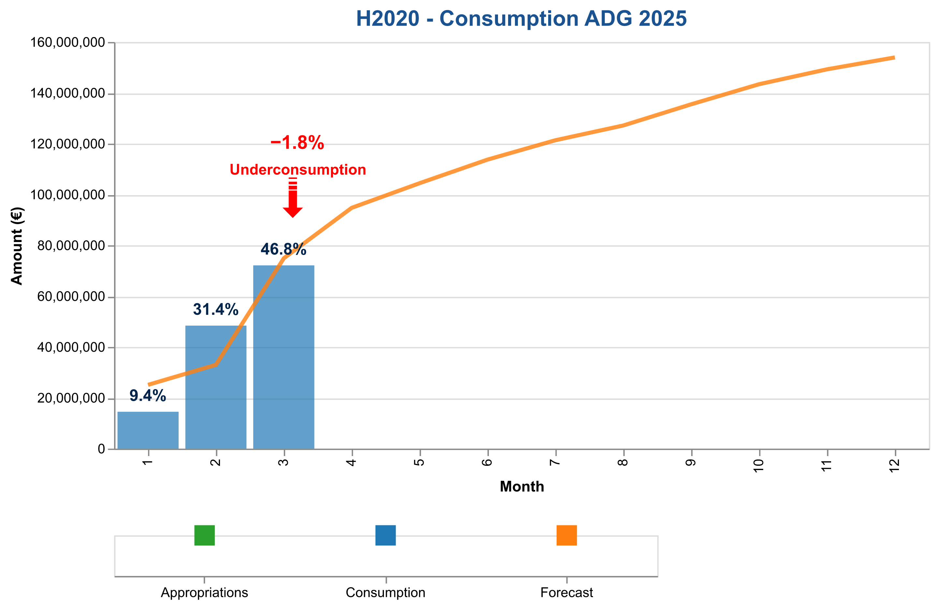

Figure 3e: Payment credits consumption of AdG payments in 2025 – H2020.

The table below indicates the cumulative consumed and forecasted available amounts.

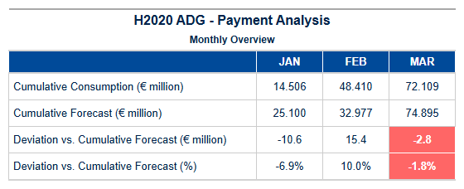

Table 6h: AdG H2020 – Cumulative consumed and forecasted available amounts.

Interim payments – SYG

### Summary of H2020 SYG Grants Payments in Q2 2025  
  
**Final Payments:**  
- **Total Amount:** €12,545,829.04  
- **Out of Which VOBU/EFTA:** €11,505,622.64  
- **Number of Transactions:** 68 (ADG), 53 (COG), 75 (STG)  
  
**Interim Payments:**  
- **Total Amount:** €59,563,018.35  
- **Out of Which VOBU/EFTA:** €58,002,922.52  
- **Number of Transactions:** 109 (ADG), 105 (COG), 79 (STG)  
  
**Deviation Analysis:**  
The cumulative paid amount for H2020 SYG grants in Q2 2025 shows a deviation from the forecast, with negative deviations starting from April onwards. By December, the deviation reaches -€31,326,805.60 compared to the forecast.  
  
This summary highlights that while interim payments are significantly higher than final payments in terms of both volume and value, there is a notable underperformance against budget forecasts as seen in the deviation analysis.

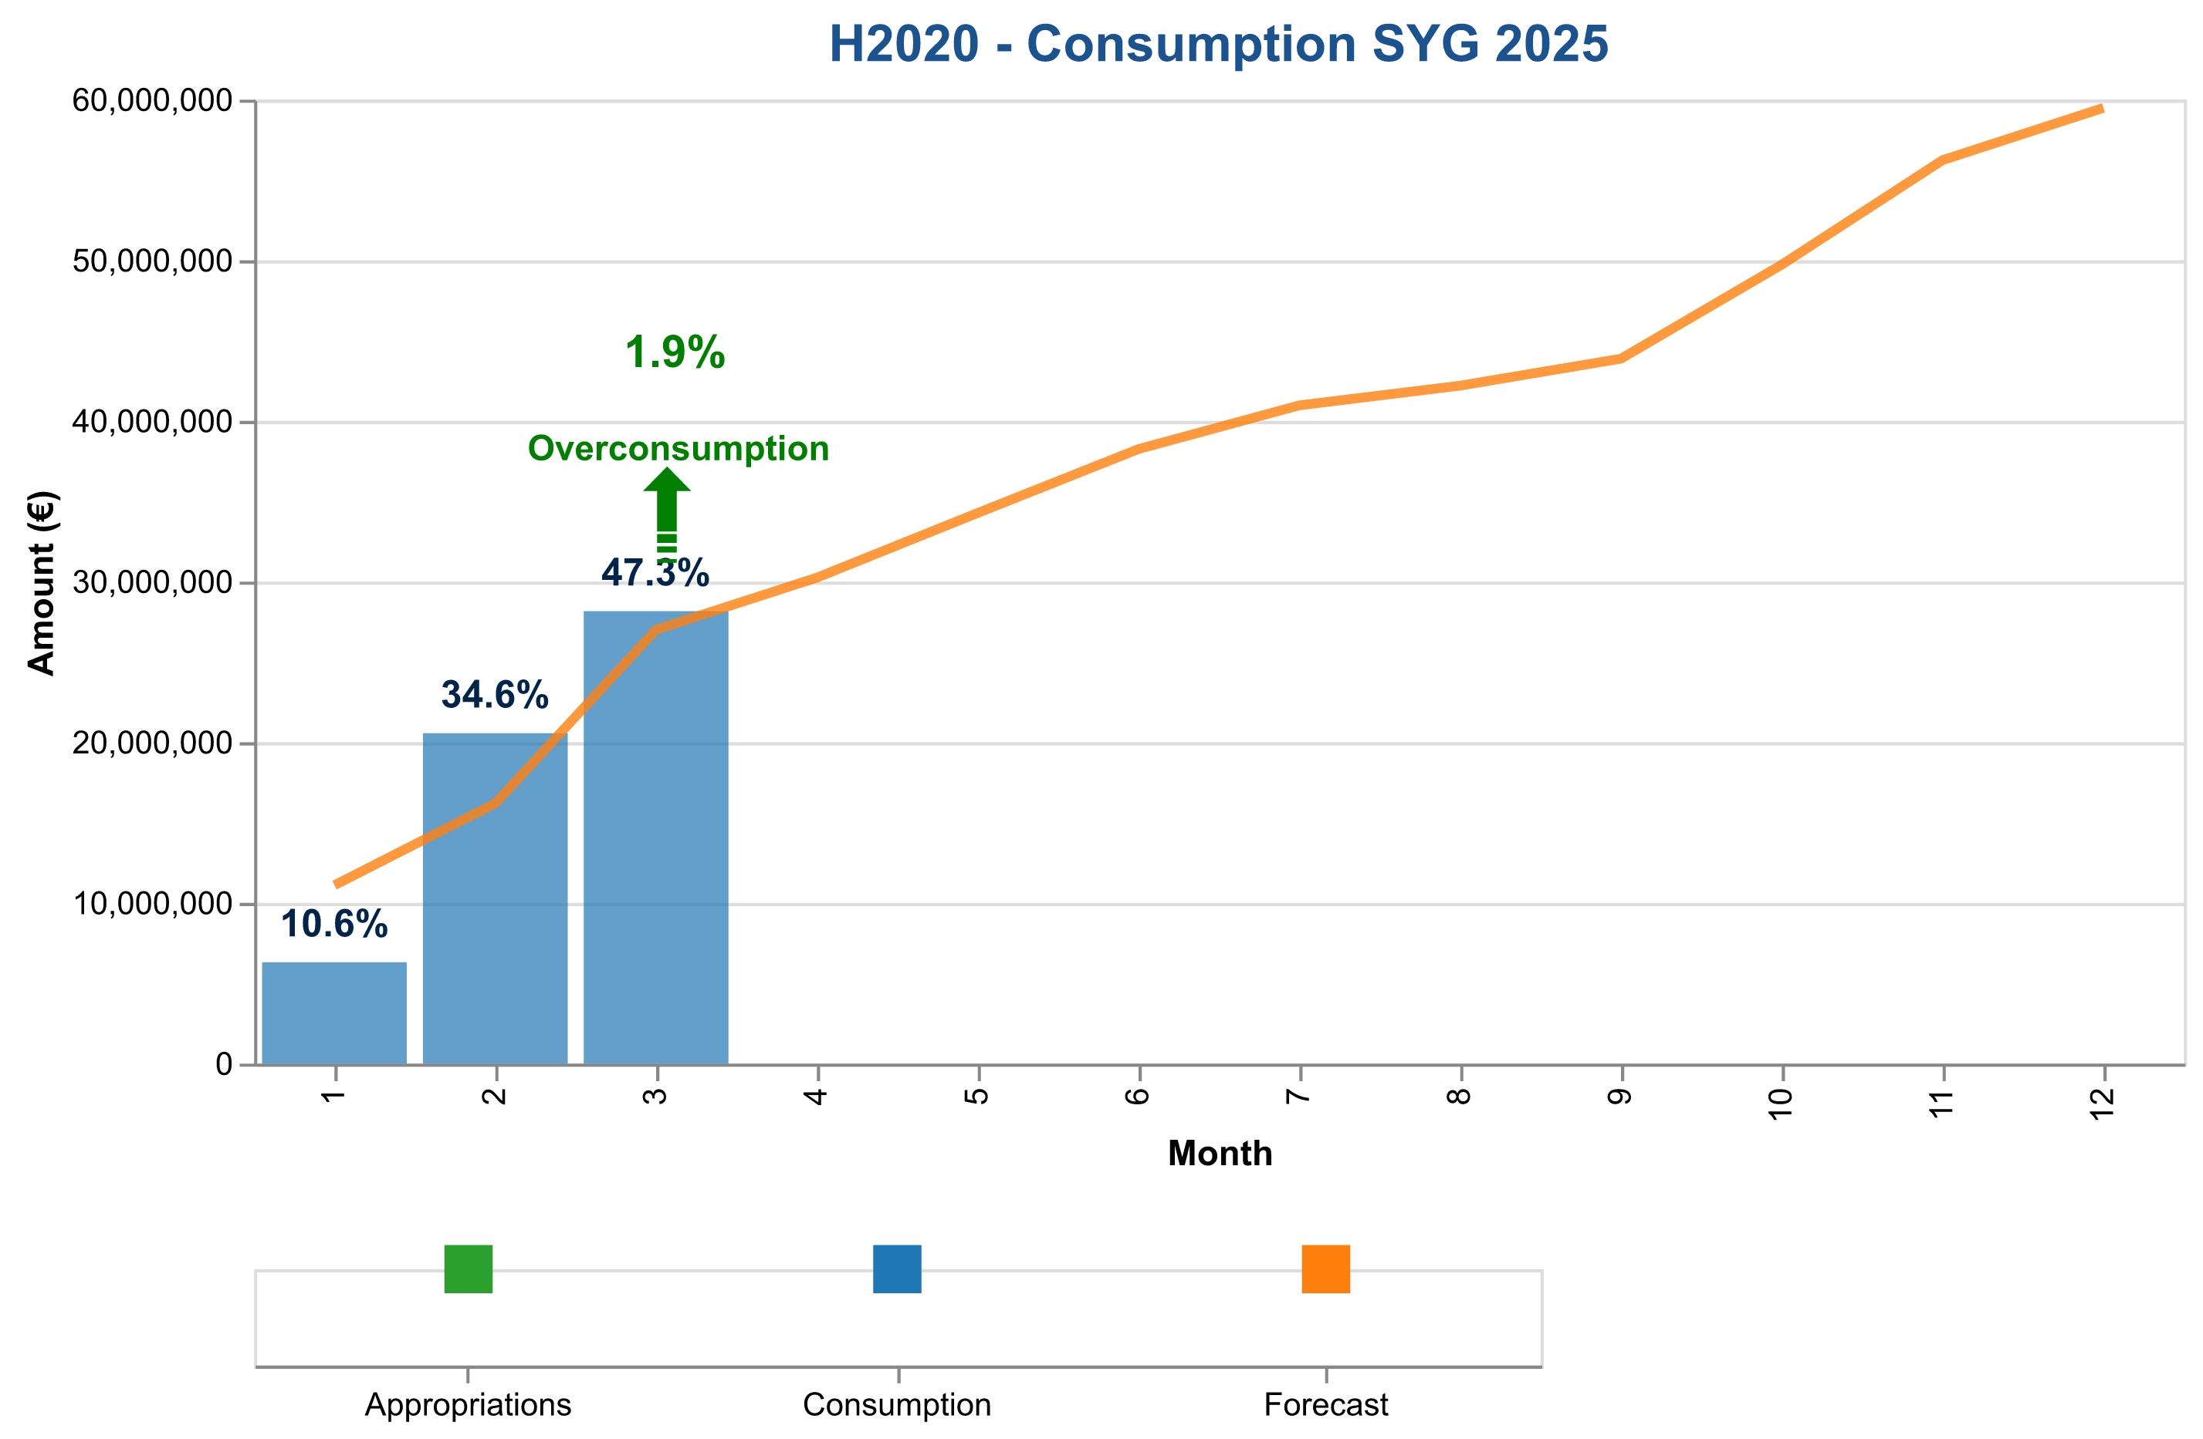

Figure 3f: Payment credits consumption of SyG payments in 2025 – H2020.

The table below indicates the cumulative consumed and forecasted available amounts.

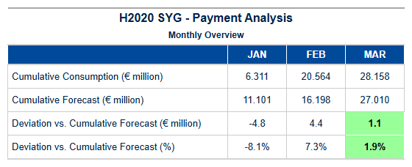

Table 6i: SyG H2020 – Cumulative consumed and forecasted available amounts.

Experts and Support Activities Payments – Amounts and Transactions

### HEU EXPERTS Grants Payment Summary for Q2 2025  
  
#### Total Payments Overview  
- **Total Amount Paid:** $39,860,969.90  
- **Number of Transactions:** 1493  
  
---  
  
#### Commentary by Type  
  
**Final:**  
- **Total Amount:** $1,632,000.00  
- **Out of Which VOBU/EFTA:** $1,541,863.75  
- **Number of Transactions:** 58  
- This category represents the final payments made, with a significant portion allocated to VOBU/EFTA.  
  
**Interim:**  
- **Total Amount:** $67,757,105.01  
- **Out of Which VOBU/EFTA:** $61,106,876.01  
- **Number of Transactions:** 138  
- Interim payments are substantial and predominantly directed towards VOBU/EFTA.  
  
**Pre-Financing:**  
- **Total Amount:** $353,767,846.70  
- **Out of Which VOBU/EFTA:** $337,996,954.45  
- **Number of Transactions:** 310  
- Pre-financing payments are the largest in volume and value, with a high percentage allocated to VOBU/EFTA.  
  
**Experts:**  
- **Total Amount:** $3,986,096.99  
- **Out of Which VOBU/EFTA:** $3,941,406.67  
- **Number of Transactions:** 1493  
- Payments to Experts are the smallest in total amount but have a high transaction volume and a significant portion allocated to VOBU/EFTA.  
  
---  
  
#### Deviation Commentary:  
The deviation analysis indicates that payments for HEU EXPERTS grants are consistently below forecasted amounts, with deviations increasing over time. By December, the cumulative payment is $3986096.99 compared to a forecast of $20,000,000, resulting in an 80.07% deviation from budget expectations.  
  
This summary provides a comprehensive overview of the financial activities for HEU EXPERTS grants in Q2 2025, highlighting significant discrepancies between actual and forecasted payments.

{{ H2020_EXPERTS_paym_analysis_chart }}

Figure 3g: Payment credits consumption of expert and support activities in 2025.

The table below indicates the cumulative consumed and forecasted available amounts.

{{ H2020_EXPERTS_paym_analysis_table }}

Table 6j: Experts H2020 – Cumulative consumed and forecasted available amounts.

{{ HEU_Experts }}

Table 6k: Experts H2020 – Payment Experts Activity.

Results of the EWS screening in {{ current_year }}

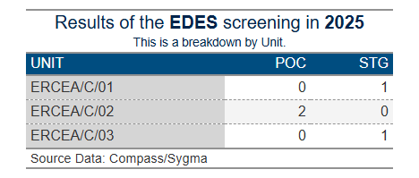

1. Time To Grant – HEU

**Article 31 of Regulation (EU) No 695/2021**, which aligns with Article 194(2) of the Financial Regulation 2018, outlines the definition of “time to grant” for grant agreements in Horizon Europe:

Time to Grant refers to the total duration measured from the closing date of the call (the final submission date for complete proposals) to the date of signature of the Grant Agreement, which should not exceed 8 months. It consists of two periods:

* Time to Inform: Successful applicants should be notified of the evaluation outcome within a maximum of 5 months from the final submission date of complete proposals.
* Time to Sign: From informing the applicants of the evaluation outcome to the signature of the grant agreements, which should not exceed a maximum of 3 months.

As per the revision note of **RTD/J3 Ref. Ares(2015)830458 dated 26/02/2015**, the duration of Time to Sign may be extended, provided that the Time to Inform does not exceed 5 months (153 calendar days), and the overall Time to Grant does not exceed 8 months (245 calendar days).

**Article 31(3) of Regulation No. 695/2021 and Article 194(2) of the Financial Regulation 2018 grant ERCEA an exception to the mentioned time limits.**



Time to Grant – From Call Deadline to Grant Signature:

This metric encompasses the duration from the call submission deadline to the signature of the Grant Agreement. The table below illustrates the average for all Grant Agreements signed by the type of call as of the end of the reporting period.

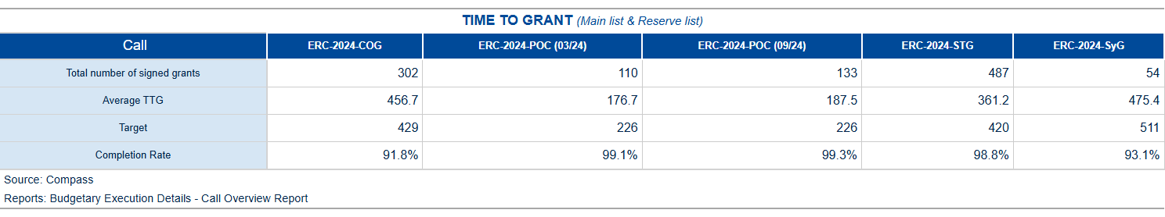

Table 7a: Average Time to Grant for the 2024-2025 calls of the HEU programme.

The table below shows the percentiles for all Grant Agreements by type of Call as of the end of the reporting period.

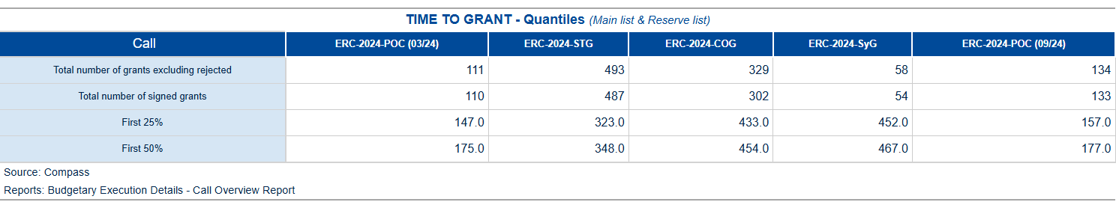

Table 7b: Time to Grant in Percentile for the 2024-2025 calls of the HEU programme.

Time to Sign – from the time of informing the applicants about the positive funding decision until the grant signature[1]

The time to sign measure covers the time taken from the moment the applicant is informed of the evaluation outcome (information letter sent) until the signature of the Grant Agreement. The table below shows the average for all Grant Agreements signed by type of call as of the end of the reporting period.

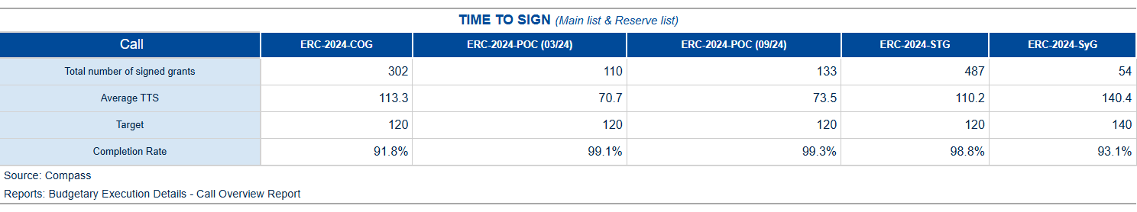

Table 7c: Average Time To Sign for the 2024-2025 calls of the HEU programme.

The table below shows the percentiles for all Grant Agreements by type of call as of the end of the reporting period.

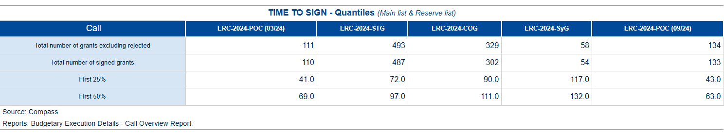

Table 7d: Time To Sign in Percentile for the 2024-2025 calls of the HEU programme.

1. Time To Invoice – Grants

In compliance with the principles of accrual accounting, and the context of the Commission’s “better budget implementation initiative”, the registration (i.e. Step 1 validation) of invoices and/or cost claims should take place within 5 working days of their receipt by the ERCEA[2].

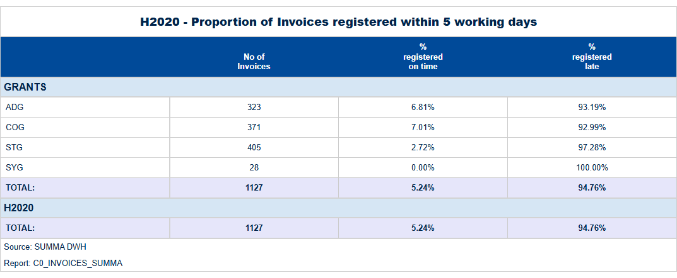

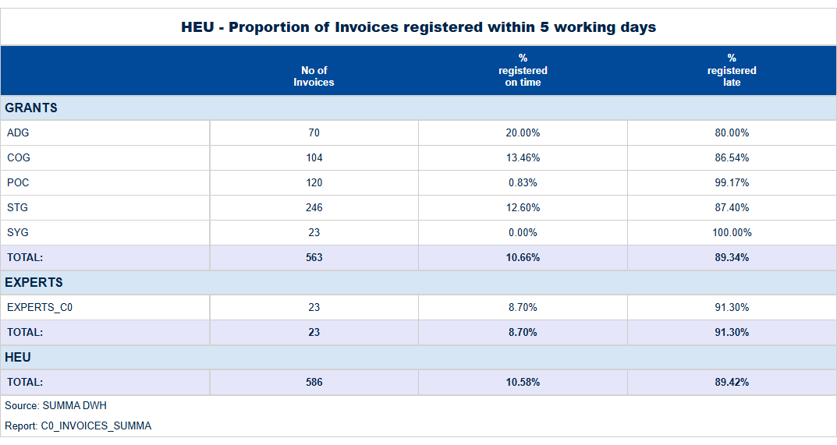

Table 8: Proportion of Transactions registered within 5 working days.

1. Time To Pay

The contractual time limit allowed for making payments to beneficiaries is 30 days for pre-financing and 90 days for interim and final payments.

Tables below:

For the H2020, and HEU programmes, the average “Time to pay” and percentage of payments executed on time.

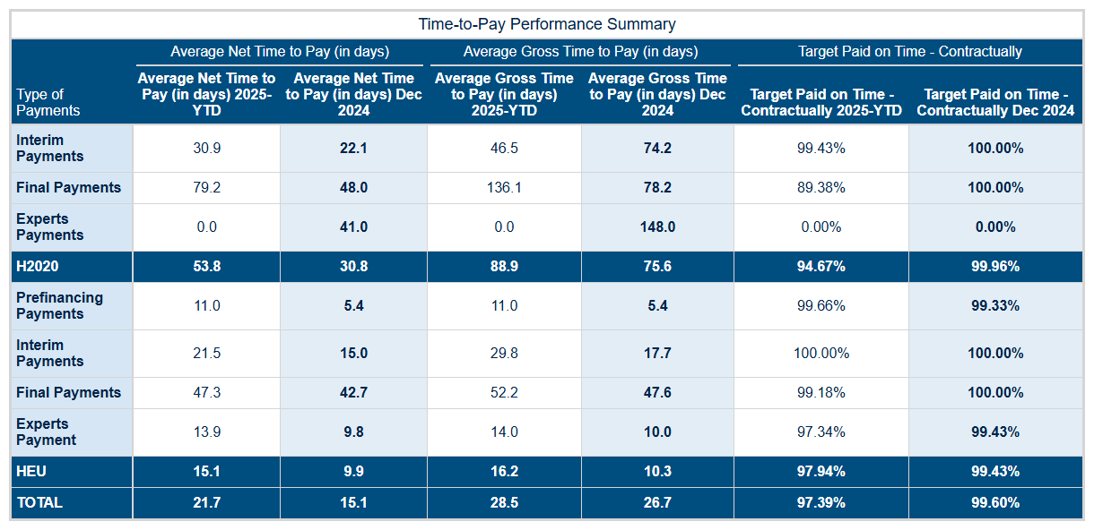

Table 9: H2020, and HEU programmes, average “Time to pay” and percentage of payments executed on time.

**Time-to-Pay Performance Analysis: Quarter 1 - 2025**  
  
In Q1 2025, our department achieved a significant milestone in payment processing efficiency by maintaining an average net time to pay (TTP) of **22.9 days**, marking a substantial improvement from the previous quarter and aligning closely with strategic objectives set forth for Horizon Europe (HEU). This accomplishment underscores our commitment to enhancing financial support mechanisms while adhering rigorously to contractual compliance standards.  
  
The analysis reveals that HEU, in particular, demonstrated exceptional performance across all payment types. For interim payments (IP), the average TTP was **22.6 days** by March 2025, a notable decrease from earlier months and reflecting an ongoing trend of process optimization within our department. Pre-financing payments (PF) also saw significant progress with an average net time to pay of just **9.2 days** in the final month of Q1, indicating robust adherence to timelines and efficient financial controls.  
  
In contrast, while H2020 interim payments showed a gradual decline from January's 55.4 days to March’s 21.4 days, this period also highlighted areas for further refinement within our processes. The initial months saw higher TTP values of **68** and **61.7 days**, which were addressed through targeted interventions aimed at streamlining verification procedures without compromising financial integrity.  
  
Our strategic focus on expert services payments (EXPERTS) yielded an impressive average net time to pay of just **13.6 days** by March, underscoring the effectiveness of our streamlined approval mechanisms for these critical transactions. This performance is crucial in ensuring timely support and compliance with contractual obligations under HEU.  
  
Looking forward, we remain committed to maintaining this level of excellence while continuously seeking opportunities for improvement. The proactive measures initiated during Q1 have laid a solid foundation for sustained efficiency gains throughout the year. Our department will continue to monitor key metrics closely, leveraging data-driven insights to optimize processes further and ensure that our financial support mechanisms meet the evolving needs of beneficiaries under both H2020 and HEU frameworks.  
  
In summary, Quarter 1 2025 saw significant strides in payment processing efficiency across all critical areas. This achievement not only reinforces our department's strategic direction but also positions us to deliver even greater value as we move forward into subsequent quarters with a renewed focus on excellence and innovation.

The figures below show the evolution of the monthly average “Time to Pay” for 2024 and compare them with the averages observed in previous years.

H2020 – TTP



Time to Pay: Interim Payments

|  |  |
| --- | --- |
|  |  |

Figure 4a: Time to Pay for Interim Payments – Monthly Evolution

Time to Pay: Final Payments

|  |  |
| --- | --- |
|  |  |

Figure 4b: Time to Pay for Final Payments – Monthly Evolution

Time to Pay: Expert and Support Activities Payments

|  |  |
| --- | --- |
| {{ H2020_EXPERTS_ttp_chart }} | {{ H2020_EXPERTS }} |

Figure 4c: Time to Pay for Final Payments – Monthly Evolution

HE – TTP

Time to Pay: Pre-financing

|  |  |
| --- | --- |
|  |  |

Figure 5a: Time to Pay for Pre-financing – Monthly Evolution

Time to Pay: Interim Payments

|  |  |
| --- | --- |
|  |  |

Figure 5b: Time to Pay for Interim Payments – Monthly Evolution

Time to Pay: Final Payments

|  |  |
| --- | --- |
|  |  |

Figure 5b: Time to Pay for Final Payments – Monthly Evolution

Time to Pay: Expert and Support Activities Payments

|  |  |
| --- | --- |
|  |  |

Figure 5c: Time to Pay for Experts – Monthly Evolution

1. Amendments – Time To Amend – H2020, HEU

H2020 – Amendments activity

In quarter_period , there were amd_received_H2020 new requests for amendments submitted by beneficiaries, out of which amd_signed_H2020 . Were signed. The table below presents an overview of the total number of amendment requests initiated by beneficiaries, formally received, and processed since the start of current_year :

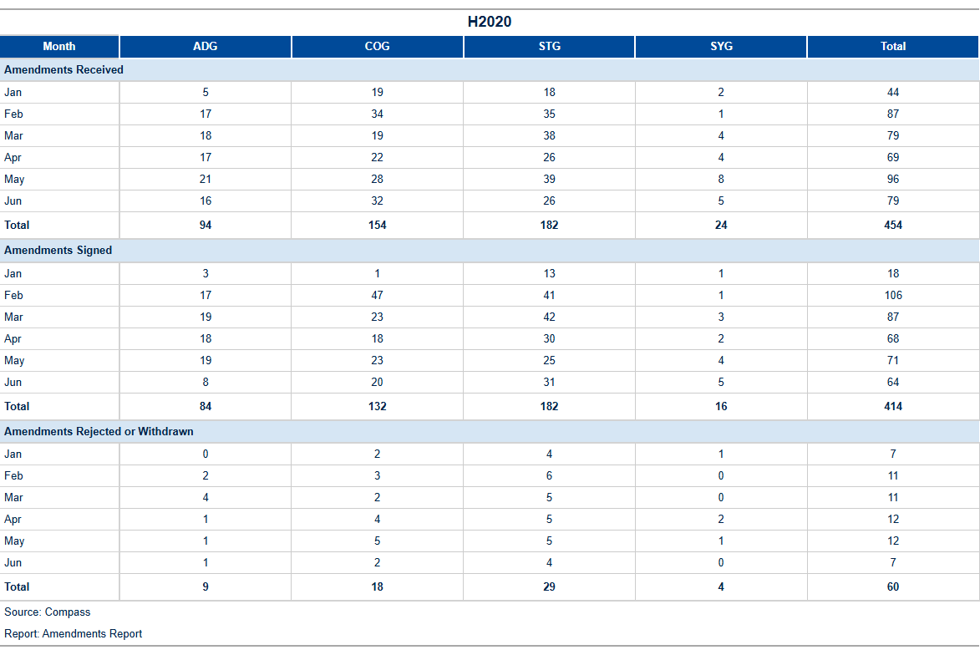

Table 10a: H2020 Amendments activity[3].

The table below shows the reasons for amendments open or signed in, and initiated by the beneficiary (one amendment request may include more than one reason):

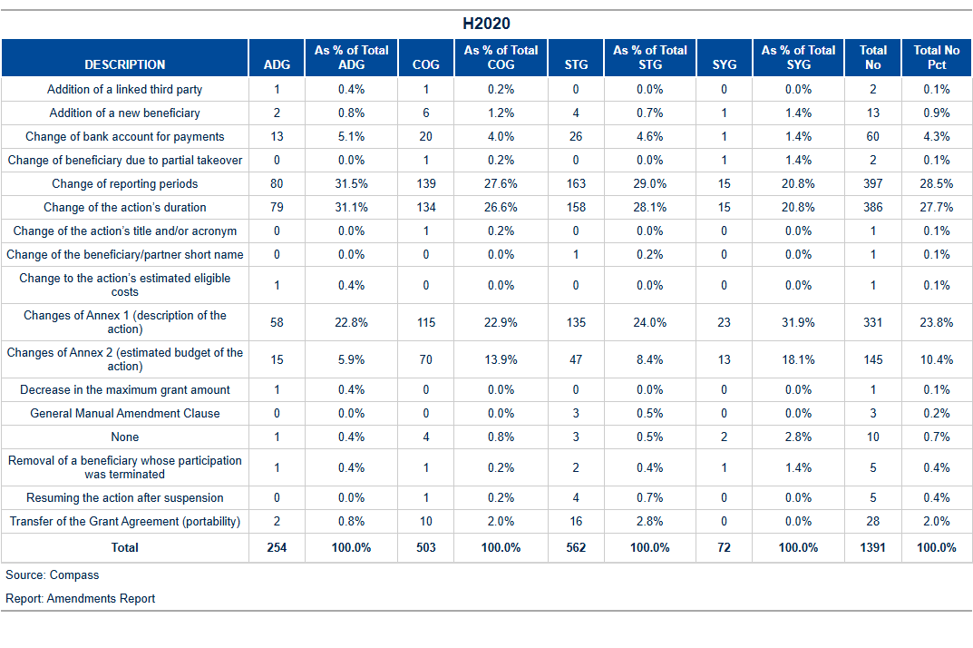

Table 10b: H2020: Reasons for amendment.

H2020 Amendments performance: Time to Amend

The current_year average time to amend is amd_TTA_H2020 days, which is below the foreseen contractual time limit of 45 days. With amd_not_ontime delayed amendments signed during the month, the yearly percentage of amendments on time is pct_amd_ontime %.

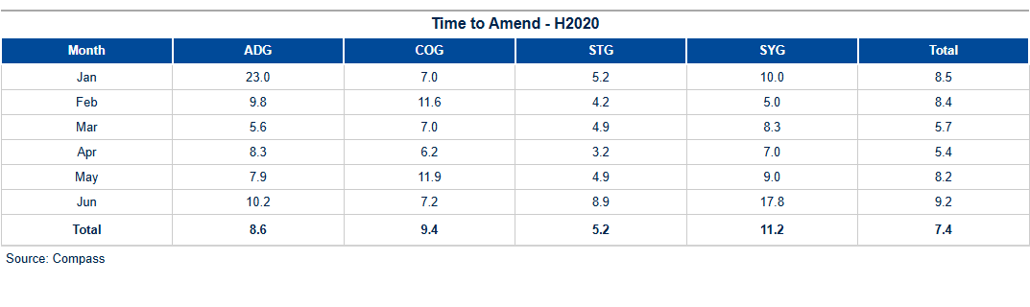

Table 10c: H2020 Time to amend.

The figure below shows the monthly evolution of the time to amend for requests initiated by beneficiaries:

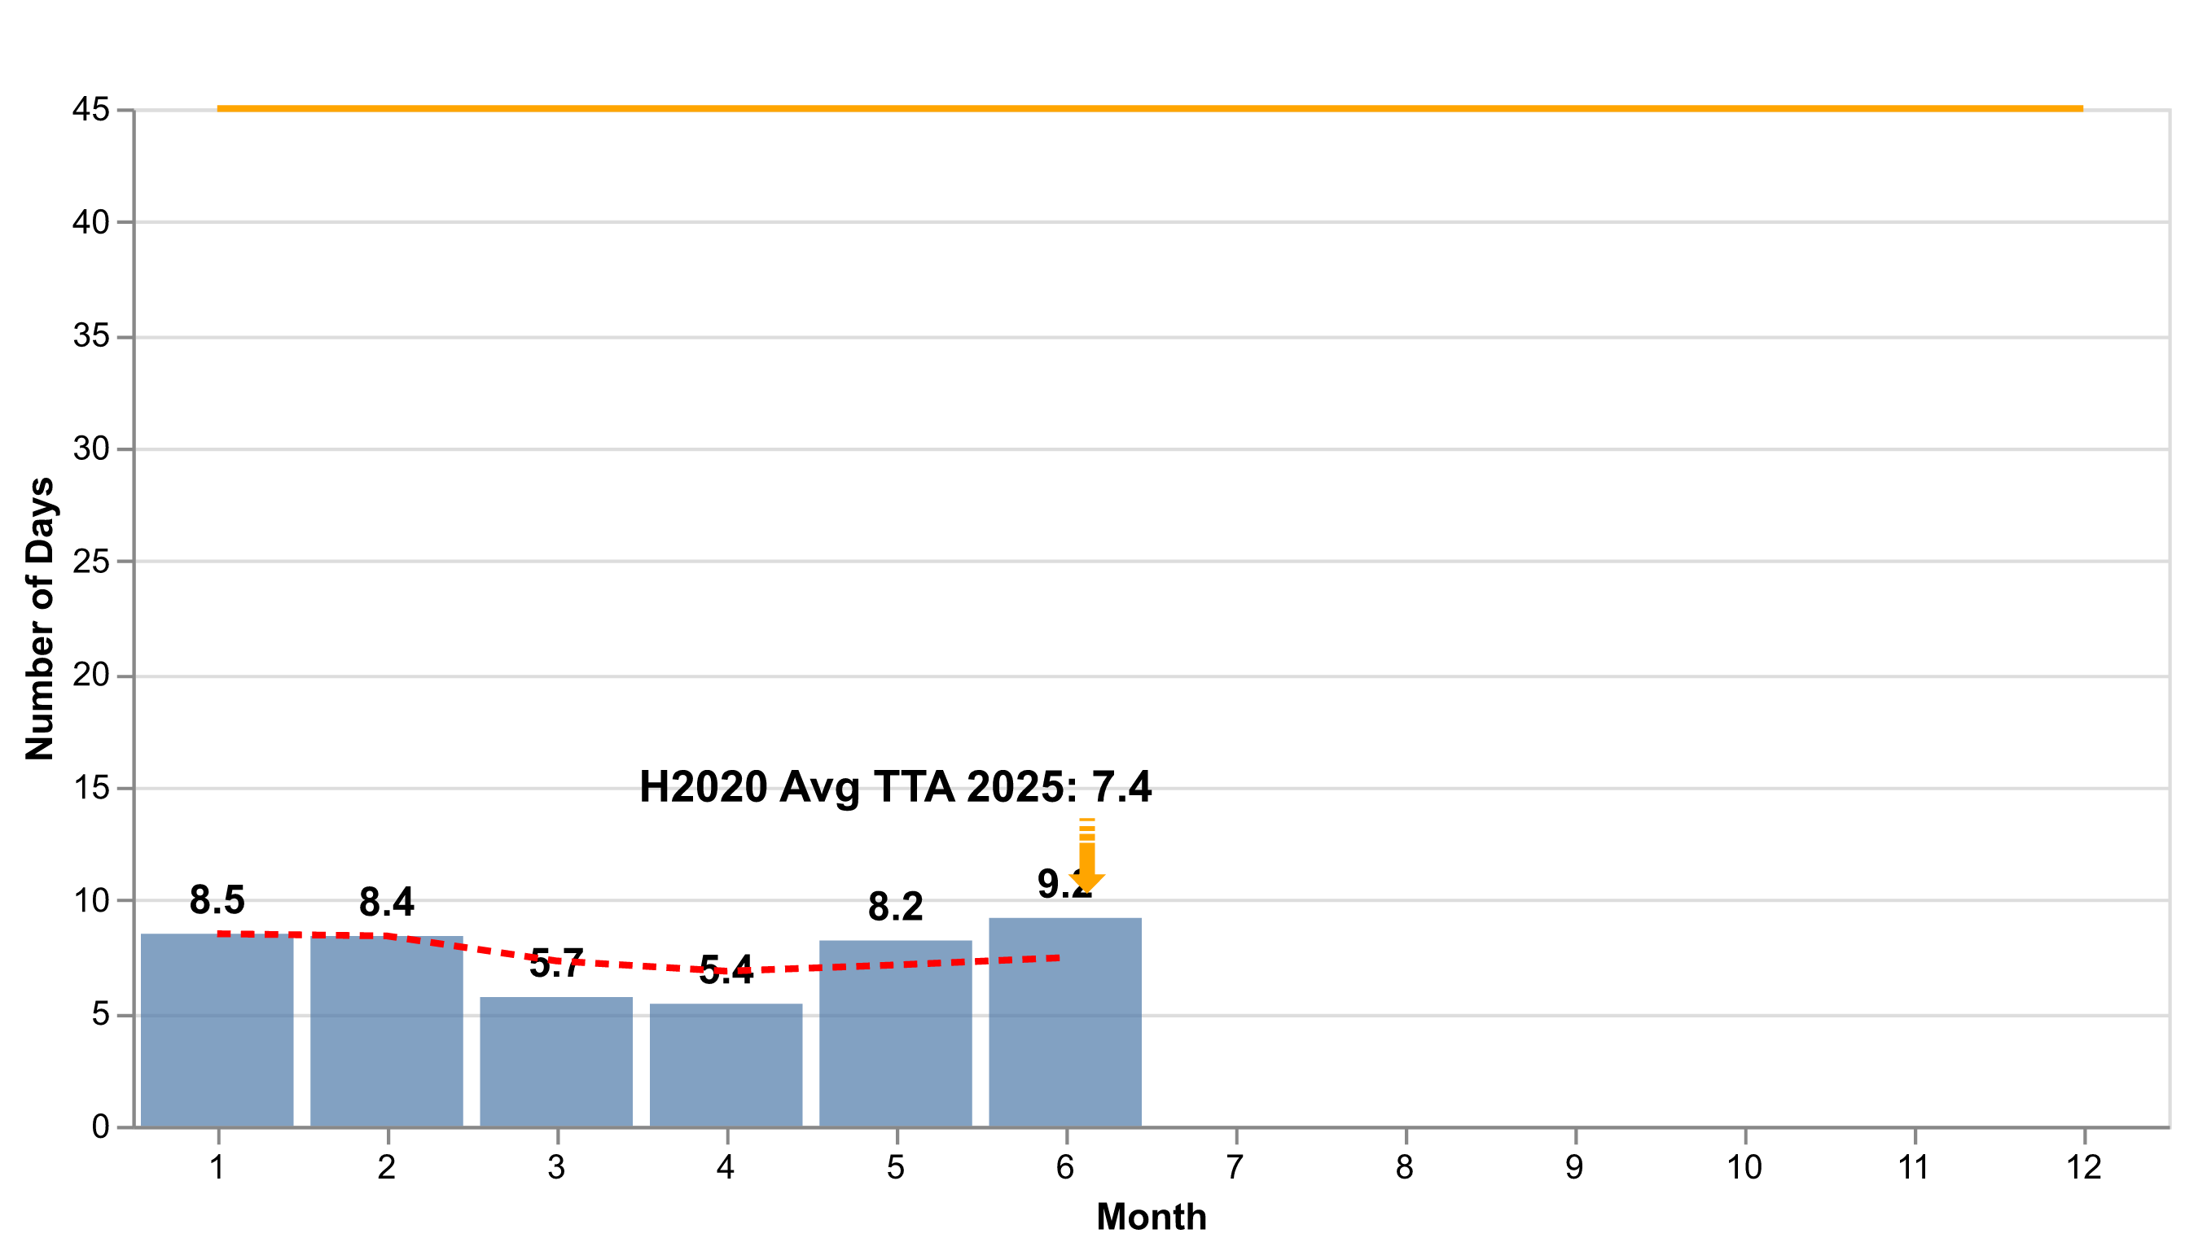

Figure 6a: H2020 Time to Amend – Monthly Evolution

HEU – Amendments activity

In quarter_period , amd_received_HEU new requests for amendments were received from beneficiaries, while amd_signed_HEU of these requests were signed. The table below offers an overview of the total number of amendment requests initiated by beneficiaries, formally received, and processed since the beginning of current_year :

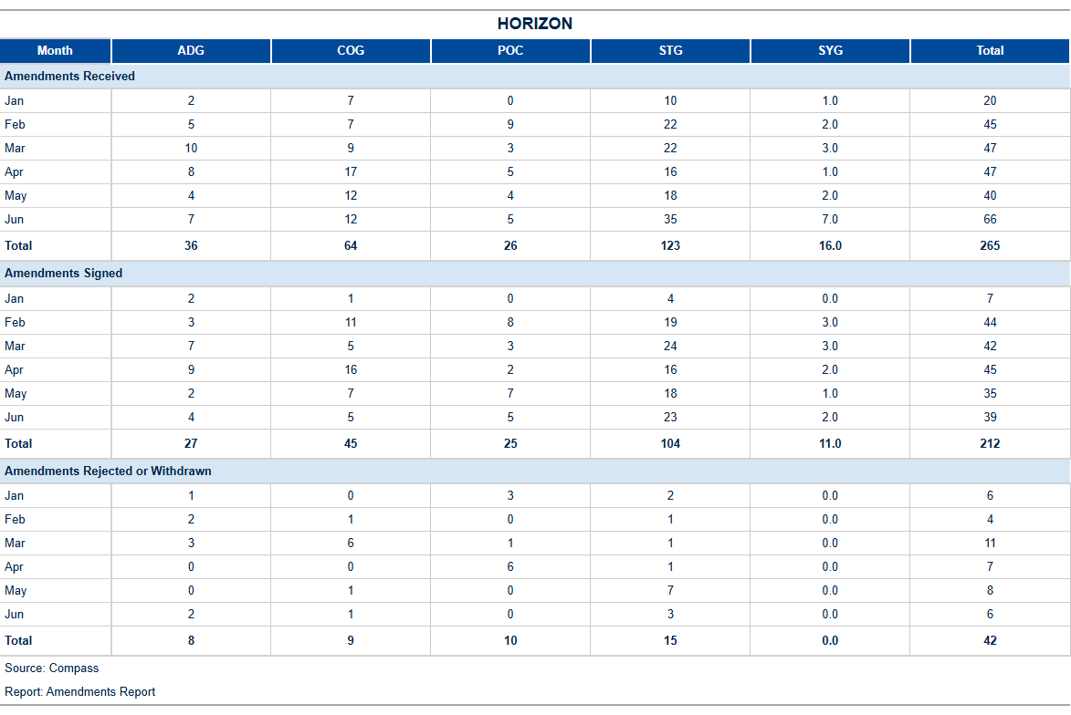

Table 10d: HEU Amendments activity[4]

The table below shows the reasons for amendments open or signed in , and initiated by the beneficiary (one amendment request may include more than one reason):

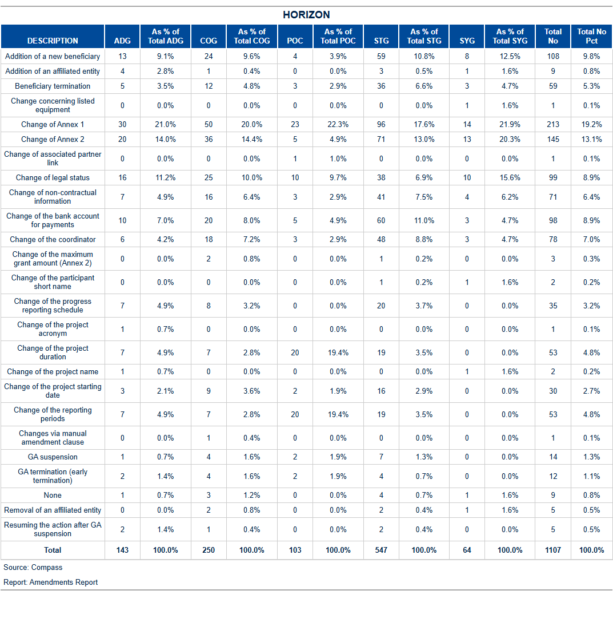

Table 10e: HEU: Reasons for amendment.

HEU Amendments performance: Time to Amend

The current_year average time to amend is amd_TTA_HEU days, which is below the foreseen contractual time limit of 45 days. With amd_not_ontime_HEU delayed amendments signed during the month, the yearly percentage of amendments on time is pct_amd_ontime_HEU %.

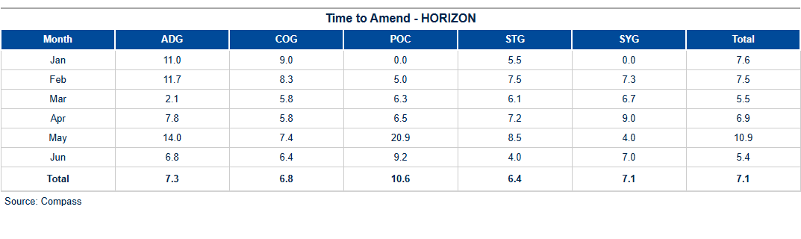

Table 10f: HEU Time to amend.

The figure below shows the monthly evolution of the time to amend for requests initiated by beneficiaries:

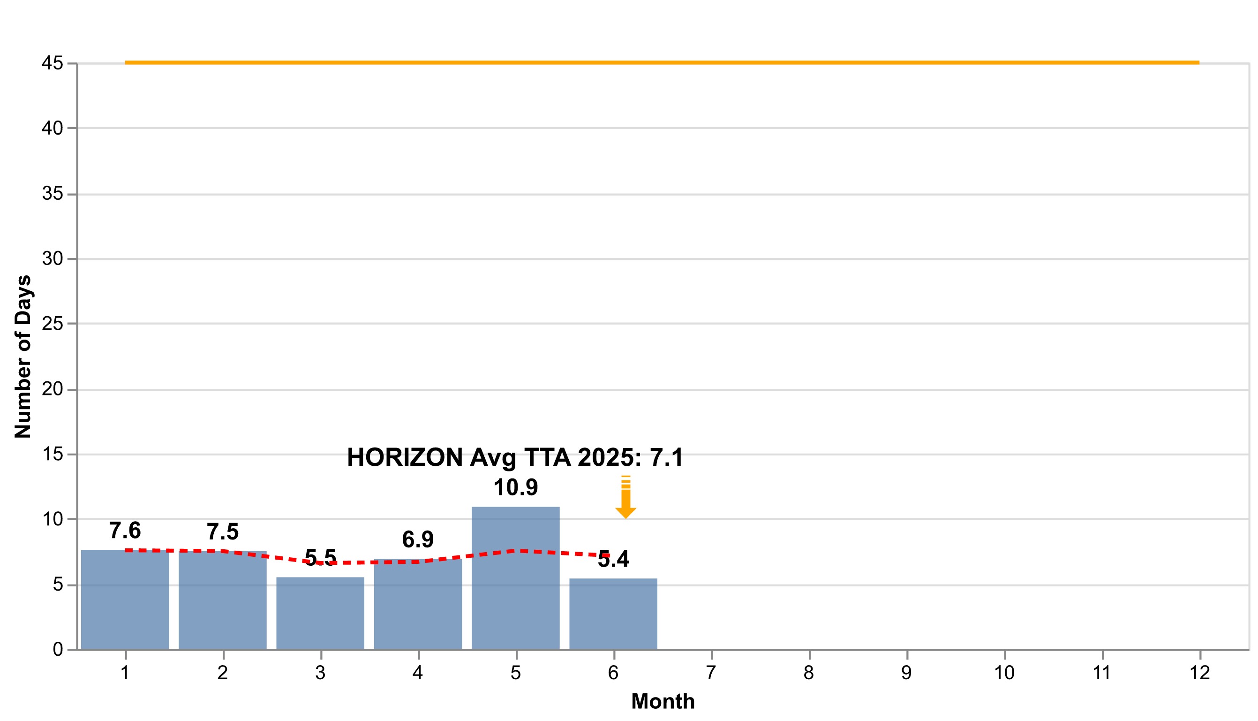

Figure 6b: H2020 Time to Amend – Monthly Evolution

1. H2020 External Audit Follow-Up – Grants

Planning and implementation of external audits

According to H2020 financial guidelines, the CIC may carry out financial audits on ERCEA projects at any time during the implementation of a project and up to five years after the end of a project.

The below shows the status of the **foreseen audits** in current_year according to the annual work programme (AWP 2024) compared to the planned/ongoing and closed ones. An audit is **planned** (or identified) when the contract with the external auditor (framework contractor) is signed or in the case of own resources, the in-house auditing team is assigned. As soon as the beneficiary receives the **announcement** **letter** (that an audit will take place at his premises) the audit is launched and considered **ongoing**.[5] By sending the **letter of conclusion** to the beneficiary the audit is **closed**.

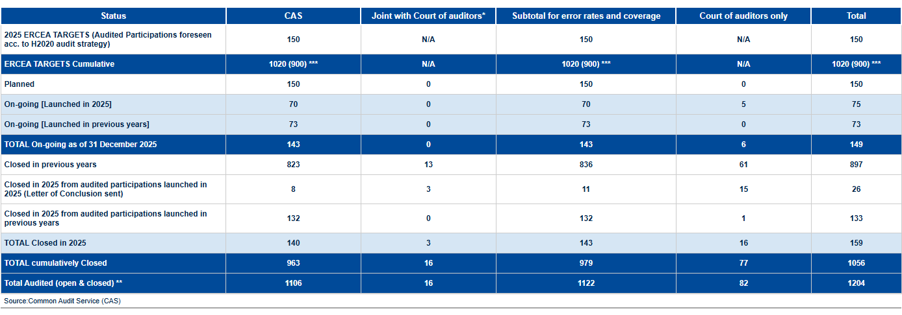

ERCEA audit programme 2024: State of play

*One audit may consist of several projects being audited at the premises of one Host Institution.*

The table below gives an overview of the error rates:

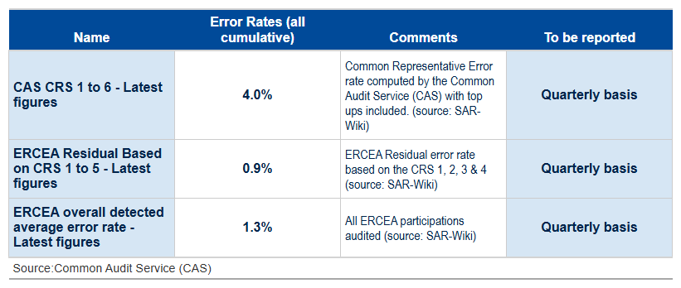

Table 11b: Error rates

The table below shows the cumulative activities on the implementation of external audits from the moment the final audit report has been sent to the beneficiary and the amount to be recovered/paid has been established (by project).

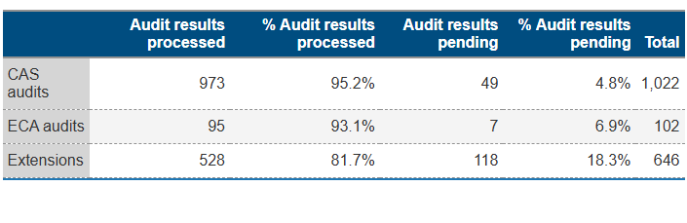

Table 11c: H2020 Implementation of the audit results (status of all ERCEA H2020 AURIs).

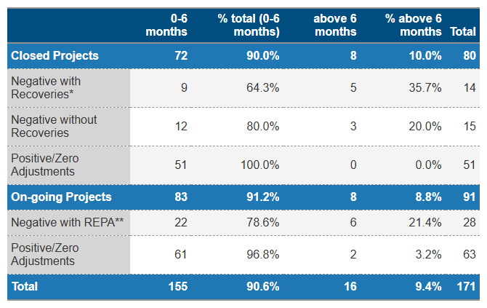

Table 11d: H2020 Implementation of the audit results (Annual Time to Implement – AURIs closed in 2024)

*On-going and closed projects with positive or zero adjustment and closed projects with negative adjustments not triggering a recovery order AURIs are finalized within 6 months*

*\* Target for closed projects with negative adjustments triggering a recovery order: at least 50% of AURI are finalized within 6 months;*

*\*\* Time to implement negative adjustments in ongoing projects = between launch of AURI workflow up to completion of Authorisation step.*

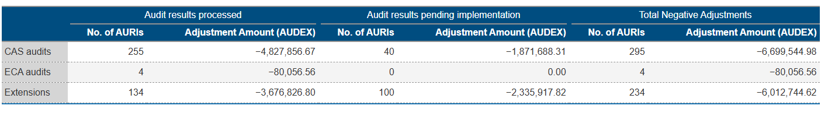

Table 11e: H2020 Implementation of the audit results (Implementation of negative adjustments – AUDEX Amounts)

*Deviations due to rounding differences (+/- 1 EUR) are excluded.*

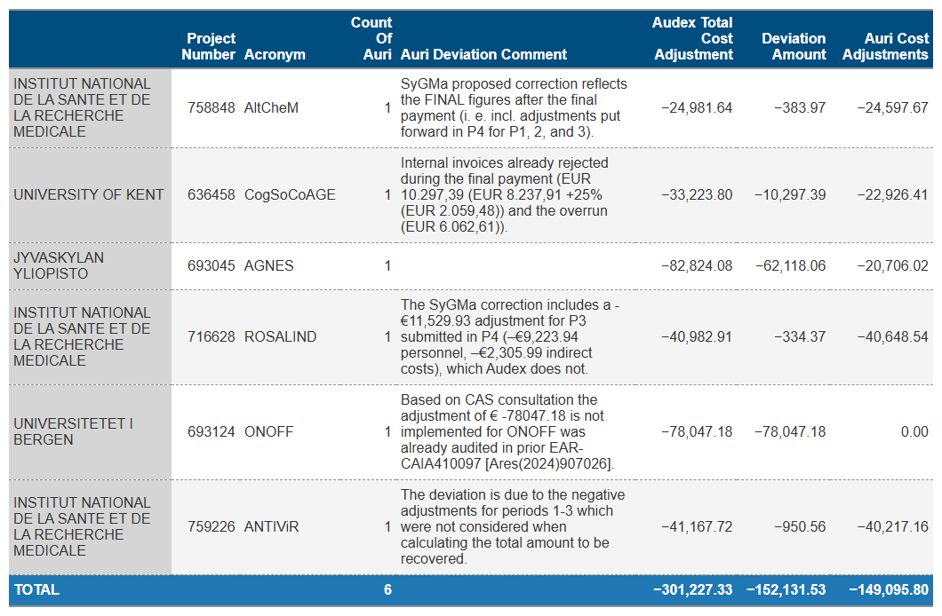

Table 11f: Deviations in implementation of negative adjustments

H2020 & HEU – Issued and cashed recovery orders

The table shows an overview of all issued, cashed/offset, and open H2020 recovery orders since the beginning of the year. Further details on the origin of the recovery orders are given in the below table.

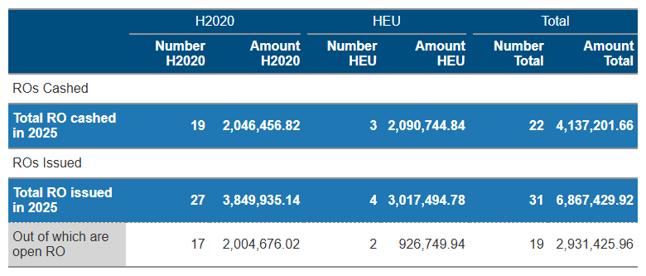

Table 12a: H2020 & HEU – recovery activity in 2025.



1. Reinforced Monitoring

This table serves as a reminder to remove the reinforced monitoring flag from projects that have exceeded their monitoring due dates. It categorizes projects according to their proximity to the due date, with a focus on highlighting those with expired flags to prompt immediate action.

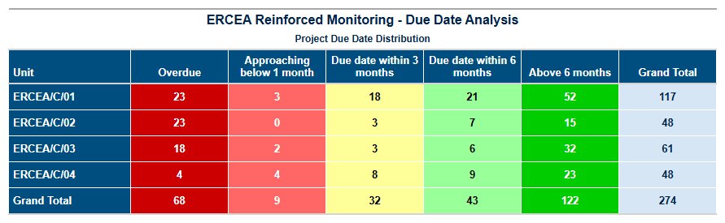

Table 13: HEU- recovery activity in 2025.

1. Guarantee Fund

H2020



Contributions to the Guarantee Fund

Nothing has been transferred to the Guarantee Fund since late 2022.

Reimbursements to Participants

Since the beginning of 2025, an amount of € 19,043,209.01 has been reimbursed from the Guarantee Fund to the participants.

Return to Budget Line

Since the beginning of 2025, an amount of € 1,413,628.89 has been returned to the budget line.

Interventions from the Guarantee Fund

None.

HEU

Contributionsions to the Guarantee Fund

Since the beginning of the 2025, an amount of € 25,465,155.12 has been transferred to the Guarantee Fund.

Figure Figure 7: HEU Contribution to the Guarantee Fund.

Reimbursements to Participants

Since the beginning of 2025, an amount of € 330,000.00 has been reimbursed from the Guarantee Fund to the participants.

Return to Budget Line

Since the beginning of 2025, no funds have been returned to the budget line.

Interventions from the Guarantee Fund

None.

1. Annex 1 – targets and indicators

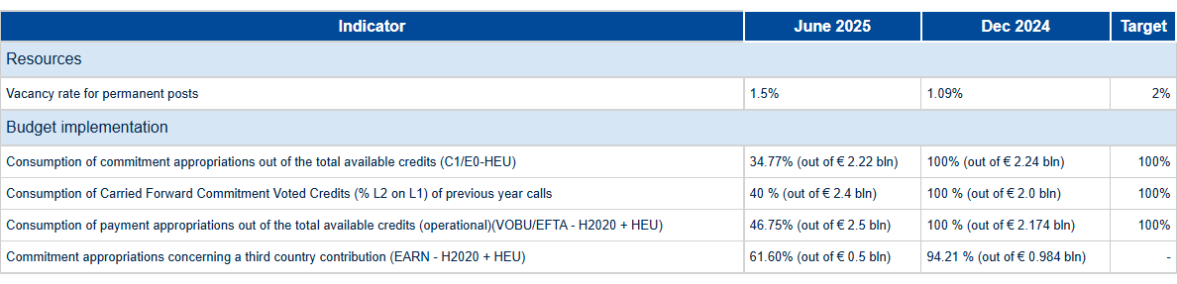

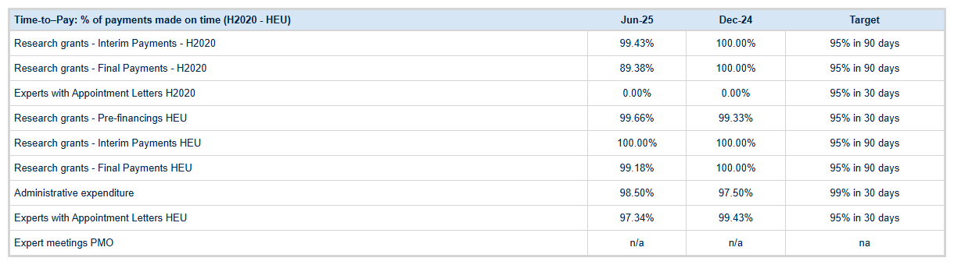

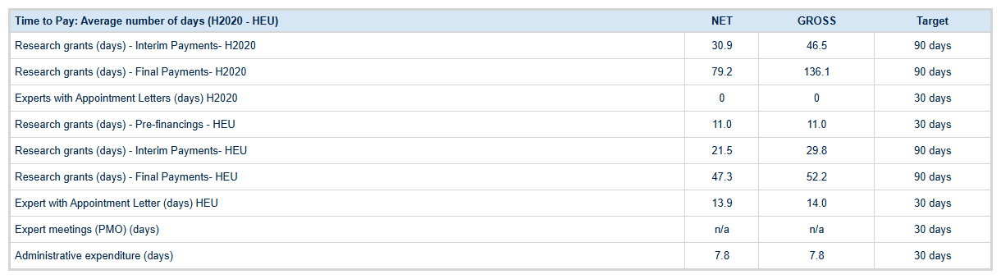

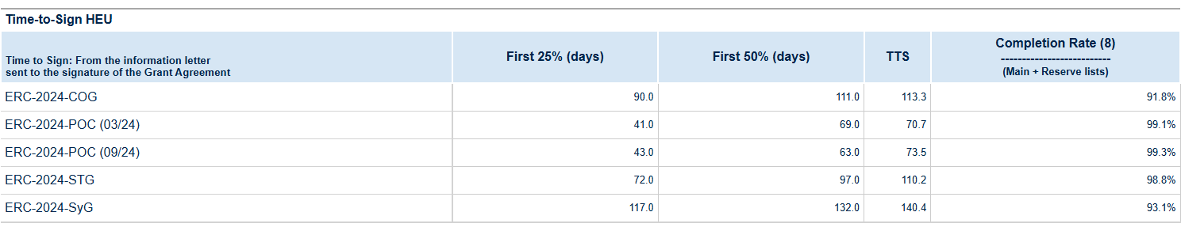

|  |  |  |  |
| --- | --- | --- | --- |
| **Time to Grant (Main and Reserve list)** |  | **Dec-24** | **Target** |
| HEU cumulatively (days) | {{ HEU_TTG_TOTA }} | 334.7 | - |
| HEU Average since 1 January (days) | 353.5 | 356.7 | - |
| **Error rate (Quarterly basis)** |  | **Dec-24** | **Target** |
| **(Last results)** |
| H2020 ERCEA average detected error rate | 1,20% | 1,29% | - |
| H2020 ERCEA residual error, based on applying the Research Family CRS error rate to ERCEA ‘s population | 0.94% | 1,02% | ≤2% |

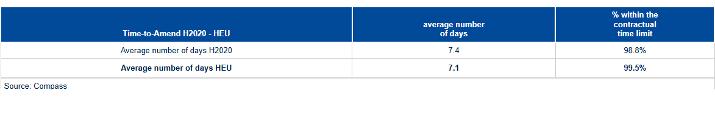

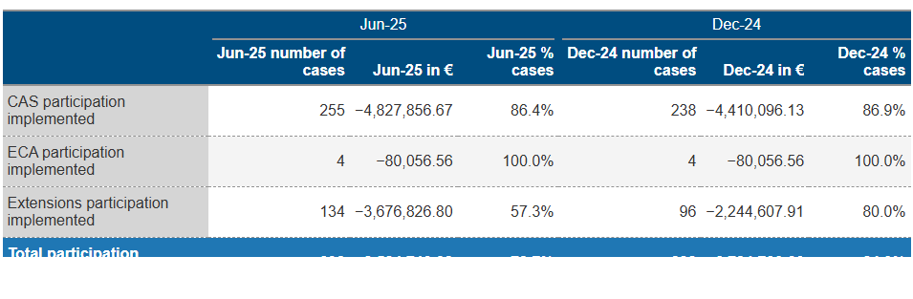

1. Annex 1 – Time to Pay

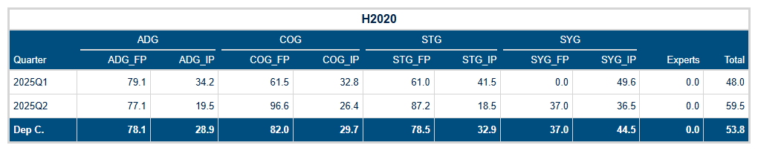

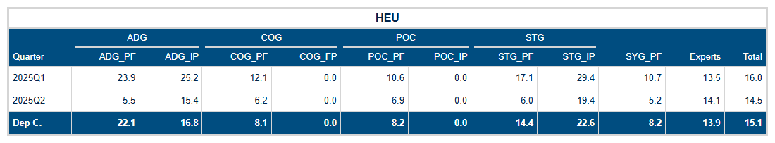

Tables 14a-14b: Time to Pay for the H2020, and HEU programmes.

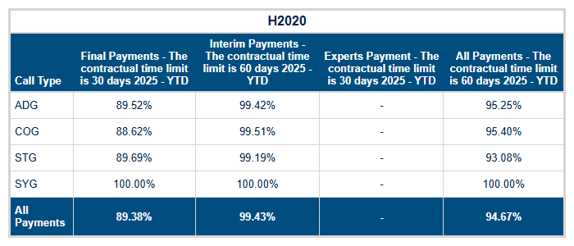

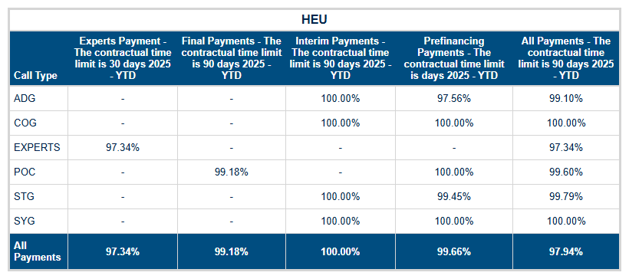

Tables 14dc-14d: Time to Pay – grant and expert payments executed on time.



Contact: Soudaina.WALA@ec.europa.eu

https://erc.europa.eu/



Designed by: Edward Smith | Edward.Smith@ec.europa.eu

Edited by: Luigi Vinciguerra | Luigi.Vinciguerra@ec.europa.eu

Contributions: Daniel Negura - Daniel.Negura@ec.europa.eu | Philippe Callens – Philippe.Callens@ec.eruopa.eu



1. Idem as footnote 5.
2. Source: ABAC Data Warehouse, Business Objects report named "DWH-Time_To_Invoice".
3. Amendments for which a specific request date have been encoded in the database. Amendments received include as well withdrawn, rejected and cancelled ones.
4. Amendments for which a specific request date have been encoded in the database. Amendments received include as well withdrawn, rejected and cancelled ones.
5. Compare the Audit Process Handbook of the European Commission.